12_Catchment_Characteristics_models

Jake Cavaiani

9/14/2022

#load libraries

.

# reading in data   
AMC <- read.csv("~/Documents/Storms_clean_repo/Output_from_analysis/08_Catchment_characteristics/Antecedent_HI_BETA_Catchment.csv")  
  
# removing a bunch of the catchment characteristic columns that are unnecessary   
AMC <- AMC[,-c(1:3,9,10,18,19,21,22,25:28,42:50,52:56,60:65,67:81,83,85,86)]  
AMC <- AMC[!duplicated(AMC$Hyst_index), ] # removing duplicated rows

# taking the mean HI for each catchment and year   
CV.all.year <- AMC %>% group_by(response_var,site.ID, year) %>%  
 dplyr::summarise(meanHI = mean(Hyst_index, na.rm = TRUE),  
 meanBETA = mean(Beta_index, na.rm = TRUE),  
 sdHI = sd(Hyst_index, na.rm = TRUE),  
 sdBETA = sd(Beta_index, na.rm = TRUE),  
 CVhi = sdHI/meanHI,  
 CVbeta = sdBETA/meanBETA,  
 CatBurn = paste(burn),  
 CatPF = paste(pf),  
 Slope = as.numeric(SLOPE_MEAN),  
 fireyear_lg = as.numeric(fireyear_lg),  
 pctburn_lg = as.numeric(pctburn_lg),  
 areaburn_lg = as.numeric(areaburn_lg),  
 PF = as.numeric(Pf_Prob_1m_mean_x),  
 NDVI = as.numeric(NDVI_p50))

## `summarise()` has grouped output by 'response_var', 'site.ID', 'year'. You can  
## override using the `.groups` argument.

CV.all.year <- CV.all.year[!duplicated(CV.all.year$meanHI), ] # removing duplicated rows  
# NDVI didnt properly merge over so manually putting in the NDVI value for each year   
CV.all.year[c(1,22,42,63),17] <- 0.192390502 # CARI 2018  
CV.all.year[c(2,23,43,64),17] <- 0.247047948 # CARI 2019  
CV.all.year[c(3,24,44,65),17] <- 0.192382581 # CARI 2020  
CV.all.year[c(4,25,45,66),17] <- NA # CARI 2021  
  
CV.all.year[c(5,26,46,67),17] <- 0.186534723 # FRCH 2018  
CV.all.year[c(6,27,47,68),17] <- 0.26075781 # FRCH 2019  
CV.all.year[c(7,28,48,69),17] <- 0.190424498 # FRCH 2020  
CV.all.year[c(8,29,49,70),17] <- NA # FRCH 2021  
  
CV.all.year[c(9,30,50,71),17] <- 0.200191538 # MOOS 2018  
CV.all.year[c(10,31,51,72),17] <- 0.258797953 # MOOS 2019  
CV.all.year[c(11,32,52,73),17] <- 0.229493425 # MOOS 2020  
CV.all.year[c(12,33,53,74),17] <- NA # MOOS 2021  
  
CV.all.year[c(13,34,54,75),17] <- 0.247071561 # POKE 2019  
CV.all.year[c(14,35,55,76),17] <- 0.217774775 # POKE 2020  
CV.all.year[c(15,36,56,77),17] <- NA # POKE 2021  
  
CV.all.year[c(16,36,57,78),17] <- 0.274414997 # STRT 2019  
CV.all.year[c(17,37,58,79),17] <- 0.23730122 # STRT 2020  
CV.all.year[c(18,38,59,80),17] <- NA # STRT 2021  
  
CV.all.year[c(19,39,60,81),17] <- 0.229493954 # VAUL 2019  
CV.all.year[c(20,40,61,82),17] <- 0.225580538 # VAUL 2020  
CV.all.year[c(21,41,62,83),17] <- NA # VAUL 2021

# scaling data #   
#scaling #   
CV.all.year[c("Slope", "fireyear_lg", "pctburn_lg", "areaburn_lg", "PF", "NDVI")] <- lapply(CV.all.year[c("Slope", "fireyear_lg", "pctburn_lg", "areaburn_lg", "PF", "NDVI")], function(x) c(scale(x)))  
  
CV_all_year_NO3 = subset(CV.all.year, response_var == "NO3")  
# fDOM #  
CV_all_year_fDOM = subset(CV.all.year, response_var == "fDOM")  
# SPC #  
CV_all_year_SPC = subset(CV.all.year, response_var == "SPC")  
# turb #  
CV_all_year_turb = subset(CV.all.year, response_var == "turb")

# testing to see if outliers are real from the input data   
# VAUL_2019 for NO3 has a really low meanHI...lets investigate that   
  
# VAUL_NO3_2019 <- subset(AMC, site.ID == "VAUL" & year == "2019" & response_var == "NO3")  
#   
# mean(VAUL_NO3_2019$Hyst_index)  
#   
# ggplot(VAUL_NO3_2019, aes(Beta_index, Hyst_index)) +  
# geom_errorbar(aes(ymin = HI_ymin, ymax = HI_ymax), color = "black", alpha = 0.5, size = 0.5, width = 0.05) +  
# geom_errorbarh(aes(xmin = Beta_ymin, xmax = Beta_ymax), colour = "black", alpha = 0.5, size = .5, height = 0.05) +  
# geom_point(aes(colour = factor(site.ID), shape = pf), size = 2.5) +  
# geom_hline(yintercept = 0) + geom_vline(xintercept = 0)   
#   
# ggplot(HI_FI_NO3, aes(Beta_index, Hyst_index)) +   
# geom_errorbar(aes(ymin = HI_ymin, ymax = HI_ymax), colour = "black", alpha = 0.5, size = .5, width = 0.05)+   
# geom_errorbarh(aes(xmin = Beta_ymin, xmax = Beta_ymax), colour = "black", alpha = 0.5, size = .5, height = 0.05) +  
# geom_point(aes(colour = factor(site.ID), shape = pf), size = 2.5) +  
# geom_hline(yintercept = 0) + geom_vline(xintercept = 0) +  
# scale_color_manual(values=c("#3288BD","#FF7F00", "#A6761D", "#6A3D9A", "#66C2A5", "#E7298A")) +   
# theme_bw() +  
# ylim(-1.5, 1.5) + xlim(-1.5, 1.5)+  
# ggtitle(vn)+   
# ylab("HI") +  
# xlab("") +  
# theme(panel.border = element_blank(),   
# panel.grid.major = element_blank(),  
# panel.grid.minor = element_blank(),   
# axis.line = element_line(colour = "black"),   
# text = element_text(size = 15),  
# legend.position = "none") +  
# labs(  
# colour = "Catchment",  
# shape = "PF Extent")

# NO3

CV.all <- AMC %>% group_by(response_var,site.ID) %>%  
 dplyr::summarise(meanHI = mean(Hyst_index, na.rm = TRUE),  
 meanBETA = mean(Beta_index, na.rm = TRUE),  
 sdHI = sd(Hyst_index, na.rm = TRUE),  
 sdBETA = sd(Beta_index, na.rm = TRUE),  
 CVhi = sdHI/meanHI,  
 CVbeta = sdBETA/meanBETA,  
 CatBurn = paste(burn),  
 CatPF = paste(pf),  
 Slope = as.numeric(SLOPE_MEAN),  
 fireyear_lg = as.numeric(fireyear_lg),  
 pctburn_lg = as.numeric(pctburn_lg),  
 areaburn_lg = as.numeric(areaburn_lg),  
 PF = as.numeric(Pf_Prob_1m_mean_x),  
 NDVI = as.numeric(NDVI_p50))

## `summarise()` has grouped output by 'response_var', 'site.ID'. You can override  
## using the `.groups` argument.

CV.all <- CV.all[!duplicated(CV.all$meanHI), ] # removing duplicated rows  
  
  
CV_all_NO3 = subset(CV.all, response_var == "NO3")  
# fDOM #  
CV_all_fDOM = subset(CV.all, response_var == "fDOM")  
# SPC #  
CV_all_SPC = subset(CV.all, response_var == "SPC")  
# turb #  
CV_all_turb = subset(CV.all, response_var == "turb")  
  
NO3_data_year<- CV_all_year_NO3[,c("site.ID", "year", "meanHI", "meanBETA", "CVhi", "CVbeta", "Slope", "fireyear_lg", "pctburn_lg", "areaburn_lg", "PF", "NDVI", "CatBurn", "CatPF")]  
  
NO3_data<- CV_all_NO3[,c("site.ID", "meanHI", "meanBETA", "CVhi", "CVbeta", "Slope", "fireyear_lg", "pctburn_lg", "areaburn_lg", "PF", "NDVI", "CatBurn", "CatPF")]  
  
  
ggpairs(NO3_data_year,  
 columns = c("meanHI","Slope", "pctburn_lg", "PF"),  
 ggplot2::aes(colour = site.ID))

## Warning in cor(x, y): the standard deviation is zero  
  
## Warning in cor(x, y): the standard deviation is zero  
  
## Warning in cor(x, y): the standard deviation is zero  
  
## Warning in cor(x, y): the standard deviation is zero  
  
## Warning in cor(x, y): the standard deviation is zero  
  
## Warning in cor(x, y): the standard deviation is zero  
  
## Warning in cor(x, y): the standard deviation is zero  
  
## Warning in cor(x, y): the standard deviation is zero  
  
## Warning in cor(x, y): the standard deviation is zero  
  
## Warning in cor(x, y): the standard deviation is zero  
  
## Warning in cor(x, y): the standard deviation is zero  
  
## Warning in cor(x, y): the standard deviation is zero  
  
## Warning in cor(x, y): the standard deviation is zero  
  
## Warning in cor(x, y): the standard deviation is zero  
  
## Warning in cor(x, y): the standard deviation is zero  
  
## Warning in cor(x, y): the standard deviation is zero  
  
## Warning in cor(x, y): the standard deviation is zero  
  
## Warning in cor(x, y): the standard deviation is zero  
  
## Warning in cor(x, y): the standard deviation is zero  
  
## Warning in cor(x, y): the standard deviation is zero  
  
## Warning in cor(x, y): the standard deviation is zero  
  
## Warning in cor(x, y): the standard deviation is zero  
  
## Warning in cor(x, y): the standard deviation is zero  
  
## Warning in cor(x, y): the standard deviation is zero  
  
## Warning in cor(x, y): the standard deviation is zero  
  
## Warning in cor(x, y): the standard deviation is zero  
  
## Warning in cor(x, y): the standard deviation is zero  
  
## Warning in cor(x, y): the standard deviation is zero  
  
## Warning in cor(x, y): the standard deviation is zero  
  
## Warning in cor(x, y): the standard deviation is zero  
  
## Warning in cor(x, y): the standard deviation is zero  
  
## Warning in cor(x, y): the standard deviation is zero  
  
## Warning in cor(x, y): the standard deviation is zero

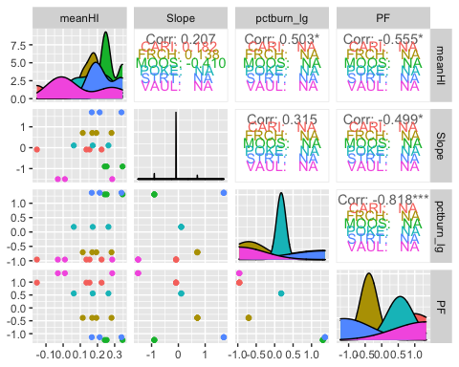

# ggsave("pairs1.pdf",  
# width = 10, height = 10)

# NO3

# HI model - year

HI.no3.year <- lmer(meanHI ~ CatPF*pctburn_lg + (1|year),   
 data = NO3_data_year)  
summary(HI.no3.year) # year is adding little variance

## Linear mixed model fit by REML ['lmerMod']  
## Formula: meanHI ~ CatPF * pctburn_lg + (1 | year)  
## Data: NO3_data_year  
##   
## REML criterion at convergence: -14.8  
##   
## Scaled residuals:   
## Min 1Q Median 3Q Max   
## -2.24725 -0.48982 0.04755 0.66644 1.54164   
##   
## Random effects:  
## Groups Name Variance Std.Dev.  
## year (Intercept) 0.001358 0.03685   
## Residual 0.012363 0.11119   
## Number of obs: 20, groups: year, 4  
##   
## Fixed effects:  
## Estimate Std. Error t value  
## (Intercept) 0.15161 0.05047 3.004  
## CatPFmedium 0.03198 0.05571 0.574  
## pctburn_lg 0.06513 0.03909 1.666  
## CatPFmedium:pctburn_lg -0.00289 0.05209 -0.055  
##   
## Correlation of Fixed Effects:  
## (Intr) CtPFmd pctbr_  
## CatPFmedium -0.781   
## pctburn_lg -0.157 0.142   
## CtPFmdm:pc_ 0.116 -0.040 -0.751

# pctburn_lg is the more significant predictor here but still relatively small with a t-value < 2  
vif(HI.no3.year)

## CatPF pctburn_lg CatPF:pctburn_lg   
## 1.031591 2.358945 2.314780

# diagnostic plot

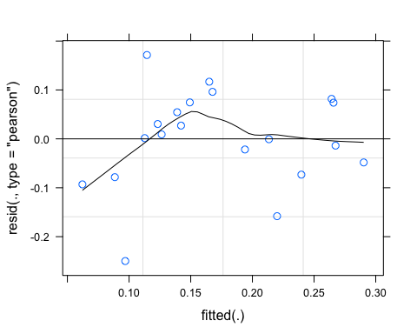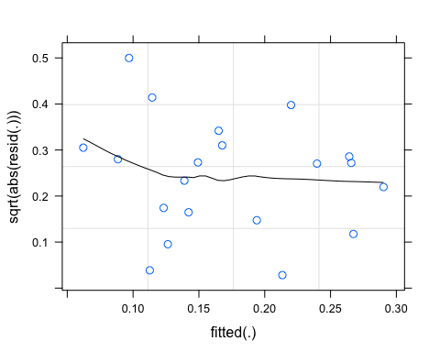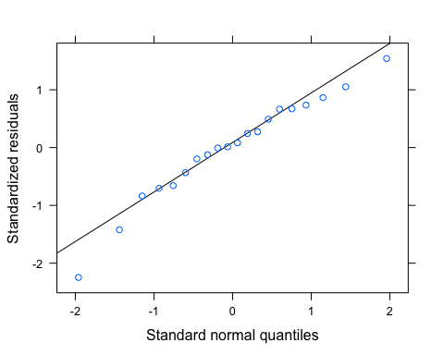

pr <- ggpredict(HI.no3.year)  
plot(pr, add.data = TRUE)

## $CatPF

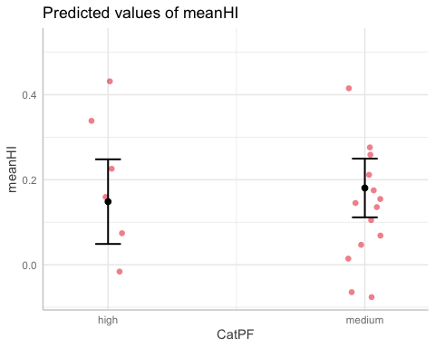

##   
## $pctburn_lg

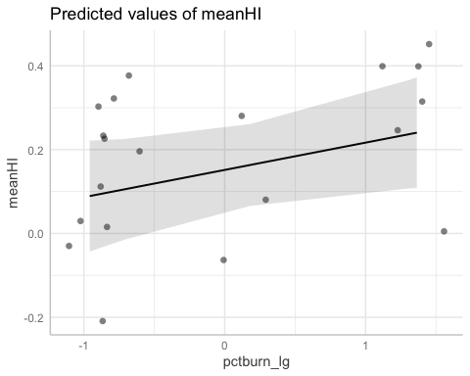

tab_model(HI.no3.year)

## Warning: Argument 'df_method' is deprecated. Please use 'ci_method' instead.

meanHI

Predictors

Estimates

CI

p

(Intercept)

0.15

0.04 – 0.26

0.009

# Trying to get a meanHI vs. pct_burn plot with two linear regression lines of best fit for categorical PF extent   
ggplot(NO3_data_year, aes(x = pctburn_lg, y = meanHI, color = CatPF)) +  
 geom_point() +  
 geom_smooth(method = "lm", na.rm = TRUE, fullrange = TRUE, aes(group = CatPF)) +  
 stat_poly_eq(formula = y~x,  
 label.y = "top", label.x = "right",  
 aes(label = paste(..eq.label.., ..rr.label.., sep = "~~~")),   
 parse = TRUE) +   
 theme_classic()

## `geom_smooth()` using formula 'y ~ x'

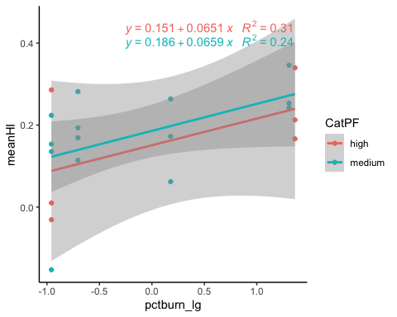

# HI model - all years

HI.no3 <- lm(meanHI ~ CatPF*pctburn_lg,   
 data = NO3_data)  
summary(HI.no3) # nothing is significant here

##   
## Call:  
## lm(formula = meanHI ~ CatPF * pctburn_lg, data = NO3_data)  
##   
## Residuals:  
## 1 2 3 4 5 6   
## -1.612e-02 5.555e-02 2.726e-02 -6.669e-02 -3.469e-18 -3.469e-18   
##   
## Coefficients:  
## Estimate Std. Error t value Pr(>|t|)  
## (Intercept) 1.460e-01 6.534e-02 2.234 0.155  
## CatPFmedium -1.191e-02 8.042e-02 -0.148 0.896  
## pctburn_lg 1.811e-03 1.372e-03 1.320 0.318  
## CatPFmedium:pctburn_lg -8.018e-05 1.869e-03 -0.043 0.970  
##   
## Residual standard error: 0.06534 on 2 degrees of freedom  
## Multiple R-squared: 0.6569, Adjusted R-squared: 0.1424   
## F-statistic: 1.277 on 3 and 2 DF, p-value: 0.4675

vif(HI.no3)

## CatPF pctburn_lg CatPF:pctburn_lg   
## 2.020353 2.197723 2.934087

plot(HI.no3)

## Warning: not plotting observations with leverage one:  
## 5, 6

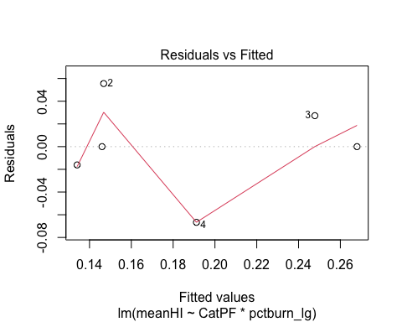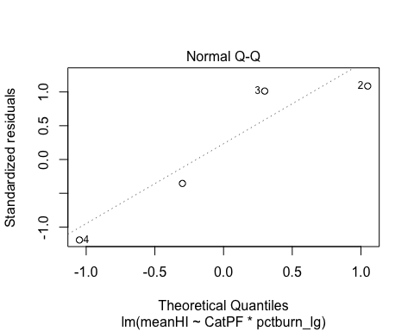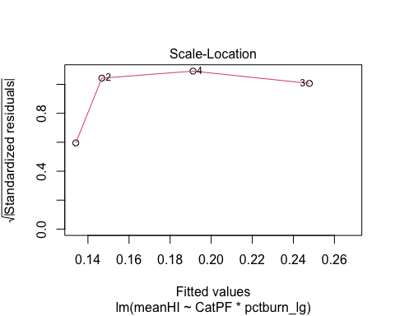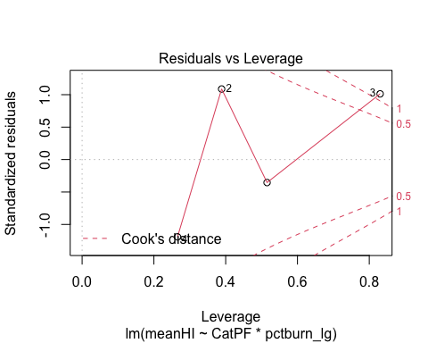

# BETA model- year

BETA.no3.year <- lmer(meanBETA ~ CatPF*pctburn_lg + (1|year),   
 data = NO3_data_year)

## boundary (singular) fit: see ?isSingular

summary(BETA.no3.year) # year is adding NO variance

## Linear mixed model fit by REML ['lmerMod']  
## Formula: meanBETA ~ CatPF * pctburn_lg + (1 | year)  
## Data: NO3_data_year  
##   
## REML criterion at convergence: 31.2  
##   
## Scaled residuals:   
## Min 1Q Median 3Q Max   
## -1.9529 -0.4818 -0.1062 0.6001 1.8620   
##   
## Random effects:  
## Groups Name Variance Std.Dev.  
## year (Intercept) 0.0000 0.0000   
## Residual 0.2364 0.4862   
## Number of obs: 20, groups: year, 4  
##   
## Fixed effects:  
## Estimate Std. Error t value  
## (Intercept) -0.62388 0.20150 -3.096  
## CatPFmedium 0.35315 0.24092 1.466  
## pctburn_lg -0.17719 0.17096 -1.036  
## CatPFmedium:pctburn_lg -0.03042 0.22729 -0.134  
##   
## Correlation of Fixed Effects:  
## (Intr) CtPFmd pctbr_  
## CatPFmedium -0.836   
## pctburn_lg -0.172 0.144   
## CtPFmdm:pc_ 0.129 -0.044 -0.752  
## optimizer (nloptwrap) convergence code: 0 (OK)  
## boundary (singular) fit: see ?isSingular

# looks like PF is the winner here but not very high   
   
vif(BETA.no3.year)

## CatPF pctburn_lg CatPF:pctburn_lg   
## 1.031177 2.369993 2.325393

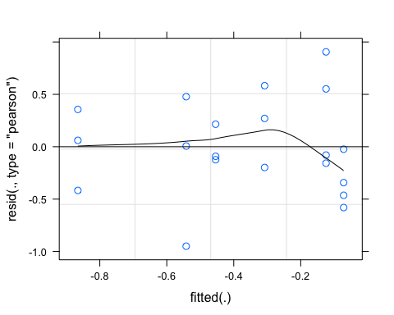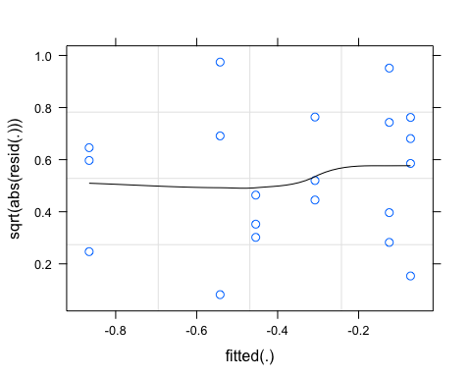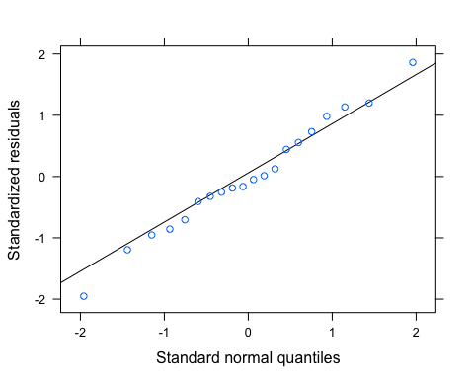

pr <- ggpredict(BETA.no3.year)  
plot(pr, add.data = TRUE)

## $CatPF

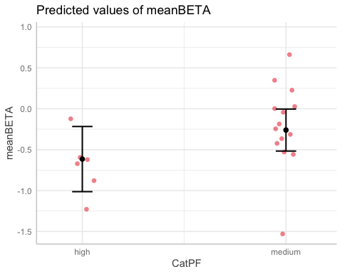

##   
## $pctburn_lg

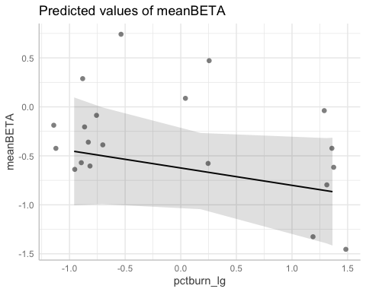

ggplot(NO3_data_year, aes(x = pctburn_lg, y = meanBETA, color = CatPF)) +  
 geom_point() +  
 geom_smooth(method = "lm", na.rm = TRUE, fullrange = TRUE, aes(group = CatPF)) +  
 stat_poly_eq(formula = y~x,  
 label.y = "top", label.x = "right",  
 aes(label = paste(..eq.label.., ..rr.label.., sep = "~~~")),   
 parse = TRUE) +   
 theme_classic()

## `geom_smooth()` using formula 'y ~ x'

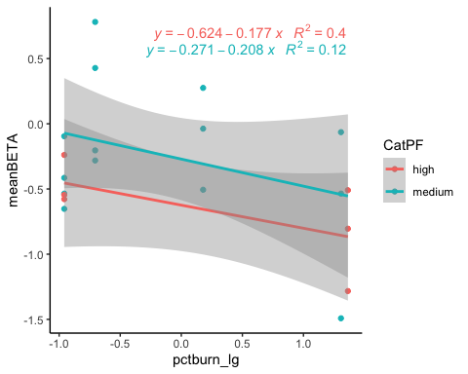

# BETA model - all years

BETA.no3 <- lm(meanBETA ~ CatPF*pctburn_lg,   
 data = NO3_data)  
summary(BETA.no3) # nothing is significant here

##   
## Call:  
## lm(formula = meanBETA ~ CatPF * pctburn_lg, data = NO3_data)  
##   
## Residuals:  
## 1 2 3 4 5 6   
## -3.183e-01 1.820e-01 -1.781e-01 3.144e-01 9.714e-17 -1.804e-16   
##   
## Coefficients:  
## Estimate Std. Error t value Pr(>|t|)  
## (Intercept) -0.393942 0.364027 -1.082 0.392  
## CatPFmedium 0.280951 0.448104 0.627 0.595  
## pctburn_lg -0.008499 0.007644 -1.112 0.382  
## CatPFmedium:pctburn_lg 0.003485 0.010415 0.335 0.770  
##   
## Residual standard error: 0.364 on 2 degrees of freedom  
## Multiple R-squared: 0.6452, Adjusted R-squared: 0.1129   
## F-statistic: 1.212 on 3 and 2 DF, p-value: 0.4818

vif(BETA.no3)

## CatPF pctburn_lg CatPF:pctburn_lg   
## 2.020353 2.197723 2.934087

plot(BETA.no3)

## Warning: not plotting observations with leverage one:  
## 5, 6

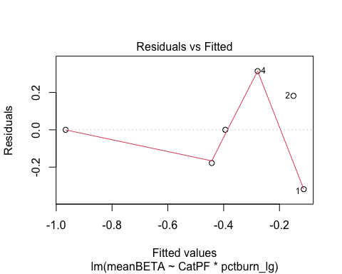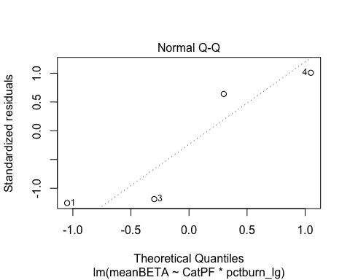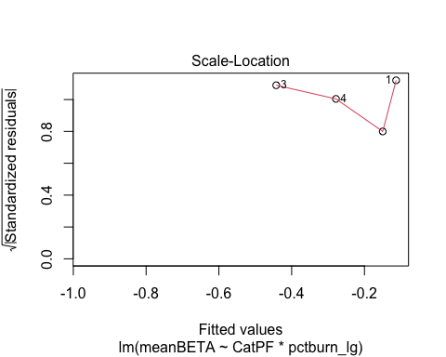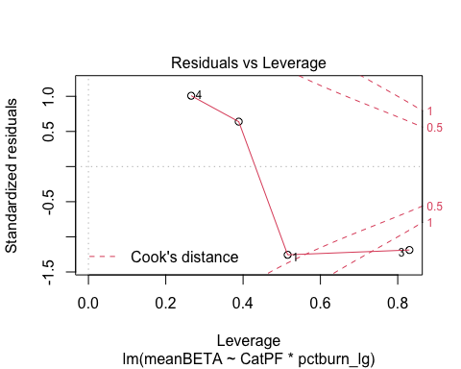

pr <- ggpredict(BETA.no3)  
plot(pr, add.data = TRUE)

## $CatPF

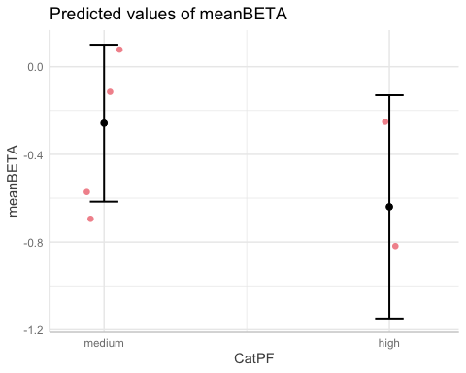

##   
## $pctburn_lg

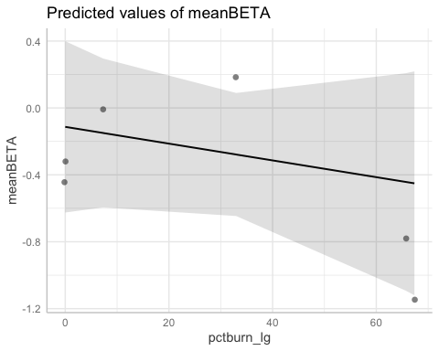

# CVHI model

CVhi.no3.year <- lmer(CVhi ~ CatPF*pctburn_lg + (1|year),   
 data = NO3_data_year)  
summary(CVhi.no3.year) # year is adding variance

## Linear mixed model fit by REML ['lmerMod']  
## Formula: CVhi ~ CatPF * pctburn_lg + (1 | year)  
## Data: NO3_data_year  
##   
## REML criterion at convergence: 121.1  
##   
## Scaled residuals:   
## Min 1Q Median 3Q Max   
## -1.97669 -0.06945 -0.02588 0.06272 3.10624   
##   
## Random effects:  
## Groups Name Variance Std.Dev.  
## year (Intercept) 1.455 1.206   
## Residual 64.052 8.003   
## Number of obs: 20, groups: year, 4  
##   
## Fixed effects:  
## Estimate Std. Error t value  
## (Intercept) 6.973 3.388 2.058  
## CatPFmedium -4.945 3.977 -1.243  
## pctburn_lg -3.508 2.814 -1.247  
## CatPFmedium:pctburn_lg 3.631 3.743 0.970  
##   
## Correlation of Fixed Effects:  
## (Intr) CtPFmd pctbr_  
## CatPFmedium -0.824   
## pctburn_lg -0.168 0.144   
## CtPFmdm:pc_ 0.126 -0.043 -0.752

#pctburn_lg narrowly edges out PF   
  
vif(CVhi.no3.year)

## CatPF pctburn_lg CatPF:pctburn_lg   
## 1.031294 2.366772 2.322276

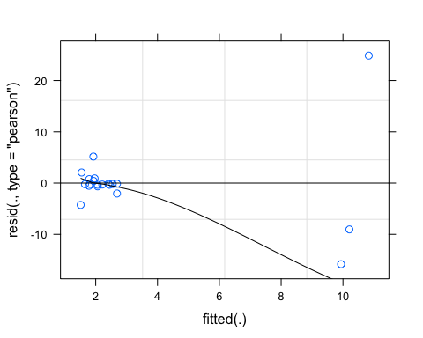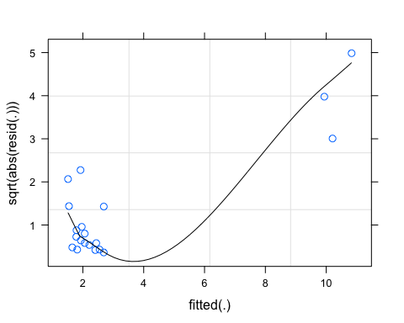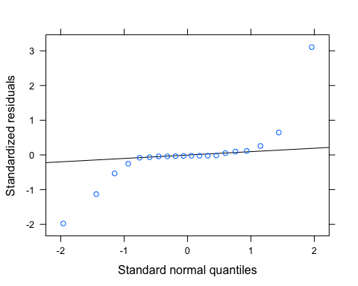

# let me log transform

NO3_data_year$logCVhi <- log(abs(NO3_data_year$CVhi))  
  
CVhi.no3.year.log <- lmer(logCVhi ~ CatPF*pctburn_lg + (1|year),   
 data = NO3_data_year)

## boundary (singular) fit: see ?isSingular

summary(CVhi.no3.year) # year is adding variance

## Linear mixed model fit by REML ['lmerMod']  
## Formula: CVhi ~ CatPF * pctburn_lg + (1 | year)  
## Data: NO3_data_year  
##   
## REML criterion at convergence: 121.1  
##   
## Scaled residuals:   
## Min 1Q Median 3Q Max   
## -1.97669 -0.06945 -0.02588 0.06272 3.10624   
##   
## Random effects:  
## Groups Name Variance Std.Dev.  
## year (Intercept) 1.455 1.206   
## Residual 64.052 8.003   
## Number of obs: 20, groups: year, 4  
##   
## Fixed effects:  
## Estimate Std. Error t value  
## (Intercept) 6.973 3.388 2.058  
## CatPFmedium -4.945 3.977 -1.243  
## pctburn_lg -3.508 2.814 -1.247  
## CatPFmedium:pctburn_lg 3.631 3.743 0.970  
##   
## Correlation of Fixed Effects:  
## (Intr) CtPFmd pctbr_  
## CatPFmedium -0.824   
## pctburn_lg -0.168 0.144   
## CtPFmdm:pc_ 0.126 -0.043 -0.752

#pctburn_lg narrowly edges out PF   
  
vif(CVhi.no3.year)

## CatPF pctburn_lg CatPF:pctburn_lg   
## 1.031294 2.366772 2.322276

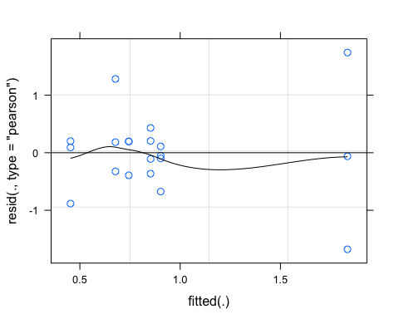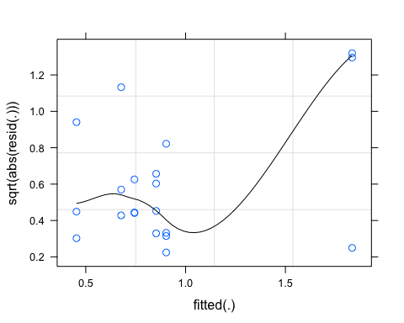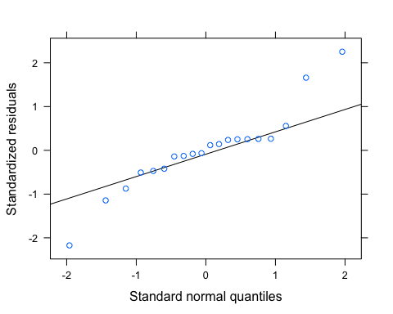

pr <- ggpredict(CVhi.no3.year)  
plot(pr, add.data = TRUE)

## $CatPF

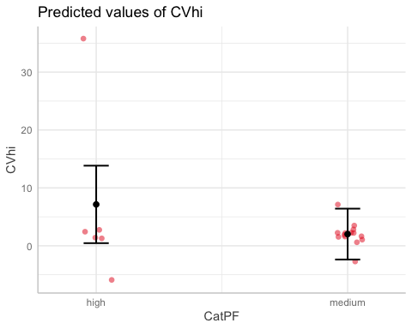

##   
## $pctburn_lg

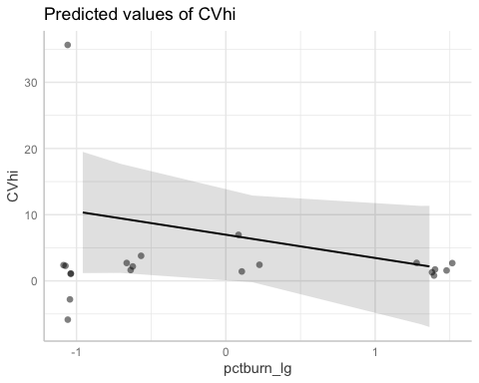

ggplot(NO3_data_year, aes(x = pctburn_lg, y = CVhi, color = CatPF)) +  
 geom_point() +  
 geom_smooth(method = "lm", na.rm = TRUE, fullrange = TRUE, aes(group = CatPF)) +  
 stat_poly_eq(formula = y~x,  
 label.y = "top", label.x = "right",  
 aes(label = paste(..eq.label.., ..rr.label.., sep = "~~~")),   
 parse = TRUE) +   
 theme_classic()

## `geom_smooth()` using formula 'y ~ x'

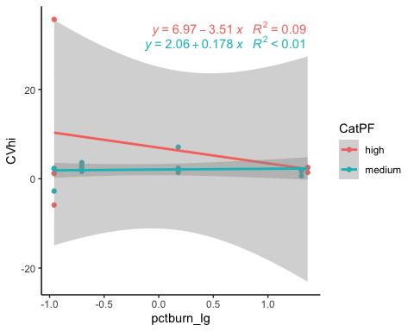

# CVBETA model

CVbeta.no3.year <- lmer(CVbeta ~ CatPF*areaburn_lg + (1|year),   
 data = NO3_data_year)  
summary(CVbeta.no3.year) # year is adding variance

## Linear mixed model fit by REML ['lmerMod']  
## Formula: CVbeta ~ CatPF * areaburn_lg + (1 | year)  
## Data: NO3_data_year  
##   
## REML criterion at convergence: 126.9  
##   
## Scaled residuals:   
## Min 1Q Median 3Q Max   
## -3.2317 -0.1143 0.2403 0.3850 0.7428   
##   
## Random effects:  
## Groups Name Variance Std.Dev.  
## year (Intercept) 11.29 3.359   
## Residual 85.69 9.257   
## Number of obs: 20, groups: year, 4  
##   
## Fixed effects:  
## Estimate Std. Error t value  
## (Intercept) -1.9124 4.3771 -0.437  
## CatPFmedium -3.0823 4.7829 -0.644  
## areaburn_lg -0.4927 3.1484 -0.157  
## CatPFmedium:areaburn_lg 0.4198 4.4129 0.095  
##   
## Correlation of Fixed Effects:  
## (Intr) CtPFmd arbrn_  
## CatPFmedium -0.777   
## areaburn_lg -0.269 0.246   
## CtPFmdm:rb_ 0.186 -0.065 -0.713

# PF is more significant but these arent really doing anything   
  
vif(CVbeta.no3.year)

## CatPF areaburn_lg CatPF:areaburn_lg   
## 1.093683 2.217994 2.092176

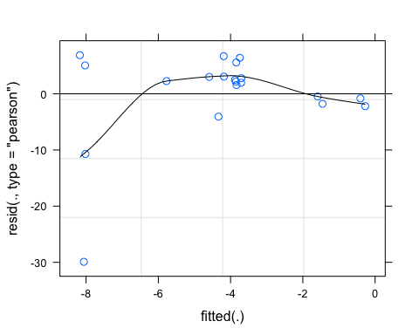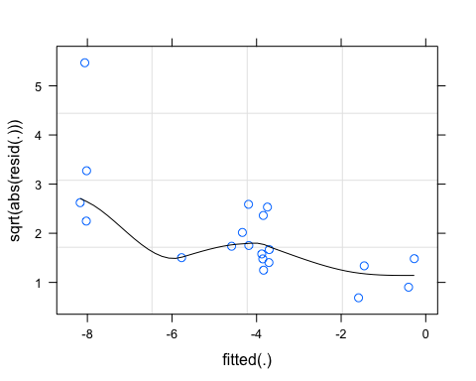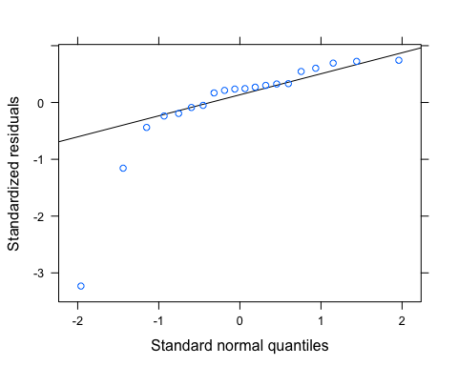 residuals dont look great. What if I log transform here

# let me log transform

NO3_data_year$logCVbeta <- log(abs(NO3_data_year$CVbeta))  
  
CVbeta.no3.year.log <- lmer(logCVbeta ~ CatPF*pctburn_lg + (1|year),   
 data = NO3_data_year)  
summary(CVbeta.no3.year.log) # year is adding variance

## Linear mixed model fit by REML ['lmerMod']  
## Formula: logCVbeta ~ CatPF * pctburn_lg + (1 | year)  
## Data: NO3_data_year  
##   
## REML criterion at convergence: 53.9  
##   
## Scaled residuals:   
## Min 1Q Median 3Q Max   
## -1.22139 -0.40673 -0.17473 0.07731 2.43870   
##   
## Random effects:  
## Groups Name Variance Std.Dev.  
## year (Intercept) 0.0924 0.3040   
## Residual 0.9051 0.9513   
## Number of obs: 20, groups: year, 4  
##   
## Fixed effects:  
## Estimate Std. Error t value  
## (Intercept) 0.7398 0.4294 1.723  
## CatPFmedium 0.3176 0.4764 0.667  
## pctburn_lg 0.2293 0.3345 0.685  
## CatPFmedium:pctburn_lg -0.1372 0.4456 -0.308  
##   
## Correlation of Fixed Effects:  
## (Intr) CtPFmd pctbr_  
## CatPFmedium -0.785   
## pctburn_lg -0.158 0.142   
## CtPFmdm:pc_ 0.117 -0.040 -0.751

#pctburn_lg narrowly edges out PF   
  
vif(CVbeta.no3.year.log)

## CatPF pctburn_lg CatPF:pctburn_lg   
## 1.031571 2.359451 2.315260

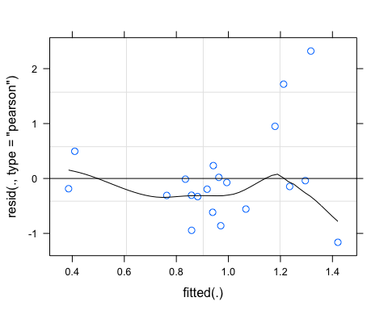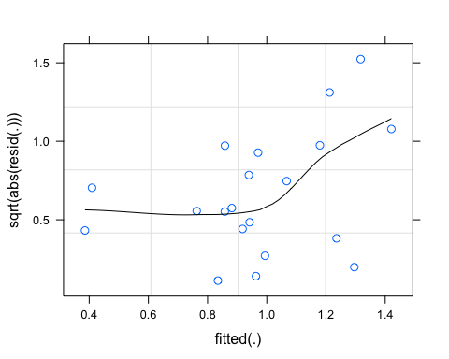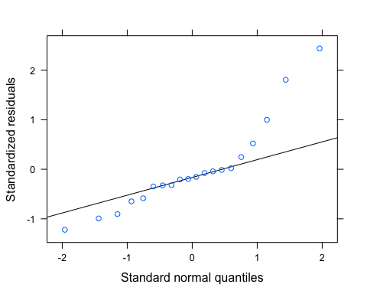 This is better but we have two big points for CARI 2020 and POKE 2020 that could be causing this issue

pr <- ggpredict(CVbeta.no3.year)  
plot(pr, add.data = TRUE)

## $CatPF

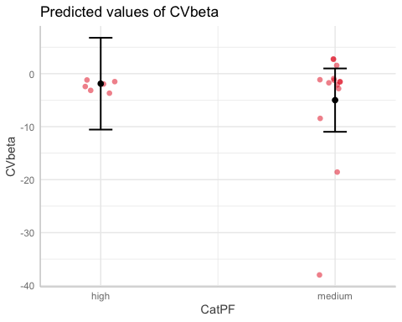

##   
## $areaburn_lg

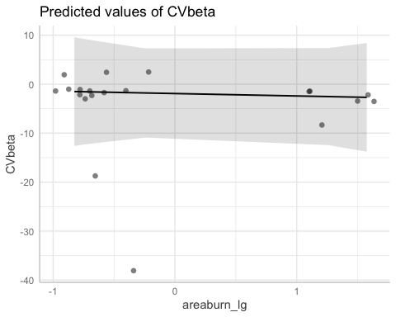

ggplot(NO3_data_year, aes(x = pctburn_lg, y = CVbeta, color = CatPF)) +  
 geom_point() +  
 geom_smooth(method = "lm", na.rm = TRUE, fullrange = TRUE, aes(group = CatPF)) +  
 stat_poly_eq(formula = y~x,  
 label.y = "top", label.x = "right",  
 aes(label = paste(..eq.label.., ..rr.label.., sep = "~~~")),   
 parse = TRUE) +   
 theme_classic()

## `geom_smooth()` using formula 'y ~ x'

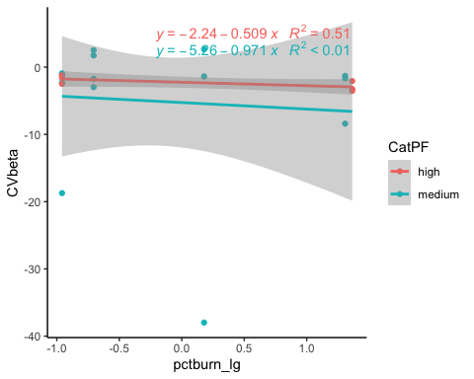

# fDOM

fDOM_data_year<- CV_all_year_fDOM[,c("site.ID", "year", "meanHI", "meanBETA", "CVhi", "CVbeta", "Slope", "fireyear_lg", "pctburn_lg", "areaburn_lg", "PF", "NDVI", "CatBurn", "CatPF")]  
  
fDOM_data<- CV_all_fDOM[,c("site.ID", "meanHI", "meanBETA", "CVhi", "CVbeta", "Slope", "fireyear_lg", "pctburn_lg", "areaburn_lg", "PF", "NDVI", "CatBurn", "CatPF")]  
  
ggpairs(fDOM_data_year,  
 columns = c("meanHI","Slope", "pctburn_lg", "PF"),  
 ggplot2::aes(colour = site.ID))

## Warning in cor(x, y): the standard deviation is zero  
  
## Warning in cor(x, y): the standard deviation is zero  
  
## Warning in cor(x, y): the standard deviation is zero  
  
## Warning in cor(x, y): the standard deviation is zero  
  
## Warning in cor(x, y): the standard deviation is zero  
  
## Warning in cor(x, y): the standard deviation is zero  
  
## Warning in cor(x, y): the standard deviation is zero  
  
## Warning in cor(x, y): the standard deviation is zero  
  
## Warning in cor(x, y): the standard deviation is zero  
  
## Warning in cor(x, y): the standard deviation is zero  
  
## Warning in cor(x, y): the standard deviation is zero  
  
## Warning in cor(x, y): the standard deviation is zero  
  
## Warning in cor(x, y): the standard deviation is zero  
  
## Warning in cor(x, y): the standard deviation is zero  
  
## Warning in cor(x, y): the standard deviation is zero  
  
## Warning in cor(x, y): the standard deviation is zero  
  
## Warning in cor(x, y): the standard deviation is zero  
  
## Warning in cor(x, y): the standard deviation is zero  
  
## Warning in cor(x, y): the standard deviation is zero  
  
## Warning in cor(x, y): the standard deviation is zero  
  
## Warning in cor(x, y): the standard deviation is zero  
  
## Warning in cor(x, y): the standard deviation is zero  
  
## Warning in cor(x, y): the standard deviation is zero  
  
## Warning in cor(x, y): the standard deviation is zero  
  
## Warning in cor(x, y): the standard deviation is zero  
  
## Warning in cor(x, y): the standard deviation is zero  
  
## Warning in cor(x, y): the standard deviation is zero  
  
## Warning in cor(x, y): the standard deviation is zero  
  
## Warning in cor(x, y): the standard deviation is zero  
  
## Warning in cor(x, y): the standard deviation is zero  
  
## Warning in cor(x, y): the standard deviation is zero  
  
## Warning in cor(x, y): the standard deviation is zero  
  
## Warning in cor(x, y): the standard deviation is zero

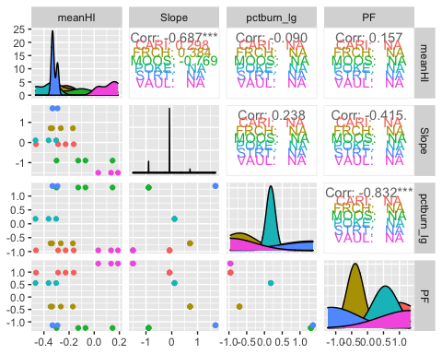

# ggsave("pairs1.pdf",  
# width = 10, height = 10)

# HI model - year

HI.fDOM.year <- lmer(meanHI ~ CatPF*pctburn_lg + (1|year),   
 data = fDOM_data_year)

## boundary (singular) fit: see ?isSingular

summary(HI.fDOM.year) # year is adding 0 variance

## Linear mixed model fit by REML ['lmerMod']  
## Formula: meanHI ~ CatPF * pctburn_lg + (1 | year)  
## Data: fDOM_data_year  
##   
## REML criterion at convergence: -12.3  
##   
## Scaled residuals:   
## Min 1Q Median 3Q Max   
## -1.8363 -0.5642 0.1039 0.5505 2.2250   
##   
## Random effects:  
## Groups Name Variance Std.Dev.  
## year (Intercept) 0.00000 0.0000   
## Residual 0.01657 0.1287   
## Number of obs: 21, groups: year, 4  
##   
## Fixed effects:  
## Estimate Std. Error t value  
## (Intercept) -0.06176 0.05335 -1.158  
## CatPFmedium -0.18283 0.06289 -2.907  
## pctburn_lg -0.18800 0.04526 -4.154  
## CatPFmedium:pctburn_lg 0.26750 0.05805 4.608  
##   
## Correlation of Fixed Effects:  
## (Intr) CtPFmd pctbr_  
## CatPFmedium -0.848   
## pctburn_lg -0.172 0.146   
## CtPFmdm:pc_ 0.134 -0.092 -0.780  
## optimizer (nloptwrap) convergence code: 0 (OK)  
## boundary (singular) fit: see ?isSingular

# pct_burn is the more significant but they are both pretty big   
  
vif(HI.fDOM.year)

## CatPF pctburn_lg CatPF:pctburn_lg   
## 1.023000 2.586499 2.553152

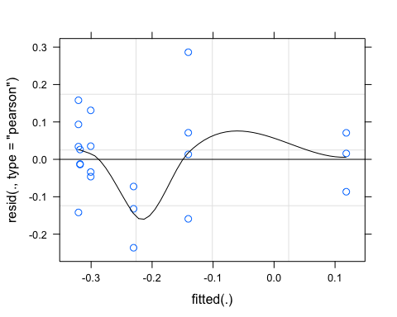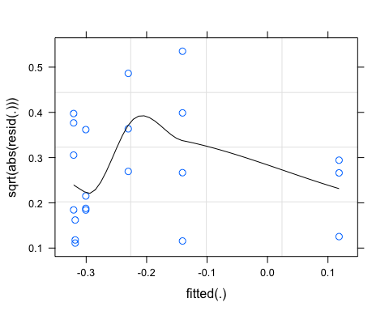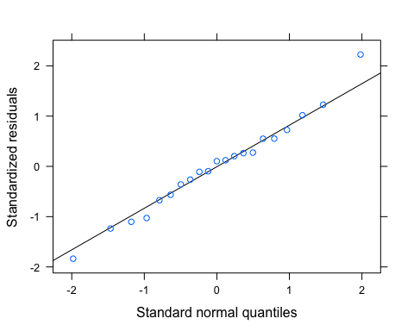

pr <- ggpredict(HI.fDOM.year)  
plot(pr, add.data = TRUE)

## $CatPF

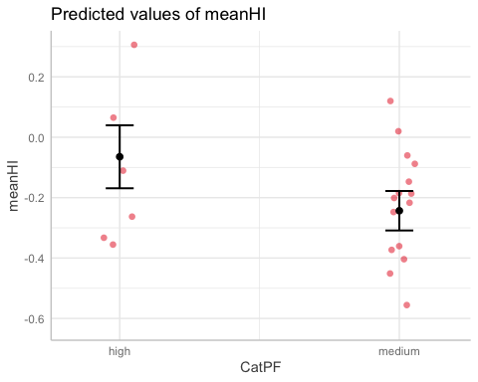

##   
## $pctburn_lg

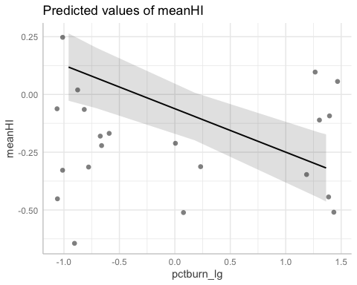

ggplot(fDOM_data_year, aes(x = pctburn_lg, y = meanHI, color = CatPF)) +  
 geom_point() +  
 geom_smooth(method = "lm", na.rm = TRUE, fullrange = TRUE, aes(group = CatPF)) +  
 stat_poly_eq(formula = y~x,  
 label.y = "top", label.x = "right",  
 aes(label = paste(..eq.label.., ..rr.label.., sep = "~~~")),   
 parse = TRUE) +   
 theme_classic()

## `geom_smooth()` using formula 'y ~ x'

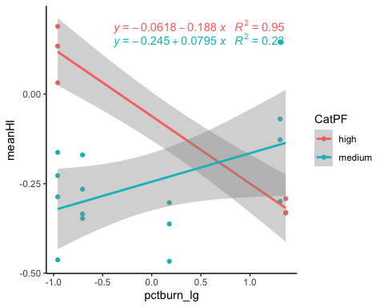

# HI model - all years

HI.fDOM <- lm(meanHI ~ CatPF*pctburn_lg,   
 data = fDOM_data)  
summary(HI.fDOM)

##   
## Call:  
## lm(formula = meanHI ~ CatPF * pctburn_lg, data = fDOM_data)  
##   
## Residuals:  
## 1 2 3 4 5 6   
## 5.619e-02 2.196e-02 7.380e-02 -1.520e-01 -2.082e-17 3.469e-17   
##   
## Coefficients:  
## Estimate Std. Error t value Pr(>|t|)  
## (Intercept) 0.114806 0.126836 0.905 0.461  
## CatPFmedium -0.453378 0.156130 -2.904 0.101  
## pctburn_lg -0.006535 0.002663 -2.454 0.134  
## CatPFmedium:pctburn_lg 0.008980 0.003629 2.475 0.132  
##   
## Residual standard error: 0.1268 on 2 degrees of freedom  
## Multiple R-squared: 0.8239, Adjusted R-squared: 0.5598   
## F-statistic: 3.119 on 3 and 2 DF, p-value: 0.2521

# nothing is significant   
plot(HI.fDOM)

## Warning: not plotting observations with leverage one:  
## 5, 6

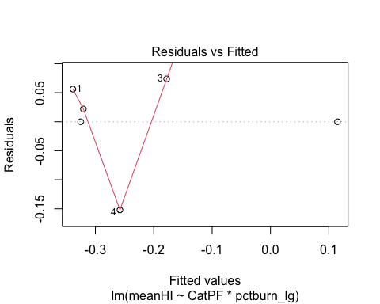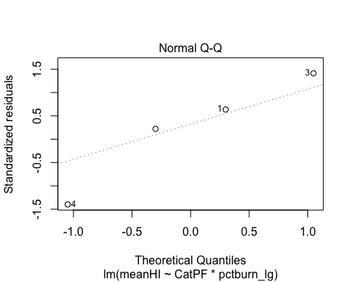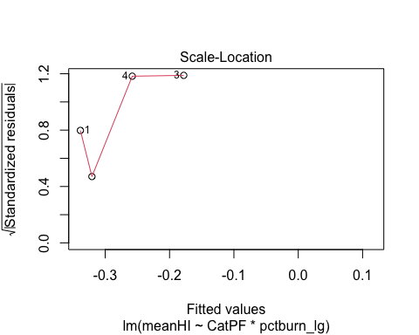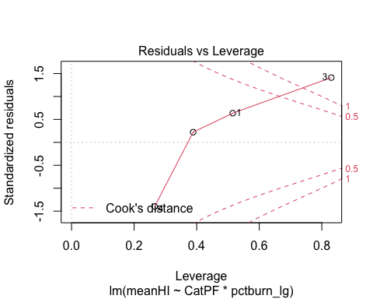

# BETA model - year

BETA.fDOM.year <- lmer(meanBETA ~ CatPF*pctburn_lg + (1|year),   
 data = fDOM_data_year)  
summary(BETA.fDOM.year) # year is adding variance

## Linear mixed model fit by REML ['lmerMod']  
## Formula: meanBETA ~ CatPF * pctburn_lg + (1 | year)  
## Data: fDOM_data_year  
##   
## REML criterion at convergence: 31.9  
##   
## Scaled residuals:   
## Min 1Q Median 3Q Max   
## -1.4267 -0.7938 -0.1110 0.5989 1.7019   
##   
## Random effects:  
## Groups Name Variance Std.Dev.  
## year (Intercept) 0.03355 0.1832   
## Residual 0.20148 0.4489   
## Number of obs: 21, groups: year, 4  
##   
## Fixed effects:  
## Estimate Std. Error t value  
## (Intercept) -0.1189 0.2117 -0.562  
## CatPFmedium 0.2583 0.2219 1.164  
## pctburn_lg 0.4130 0.1578 2.617  
## CatPFmedium:pctburn_lg -0.6185 0.2024 -3.055  
##   
## Correlation of Fixed Effects:  
## (Intr) CtPFmd pctbr_  
## CatPFmedium -0.767   
## pctburn_lg -0.151 0.144   
## CtPFmdm:pc_ 0.120 -0.093 -0.780

# pctburn is adding more individually but the interaction term in the biggest   
  
vif(BETA.fDOM.year)

## CatPF pctburn_lg CatPF:pctburn_lg   
## 1.022247 2.583659 2.552009

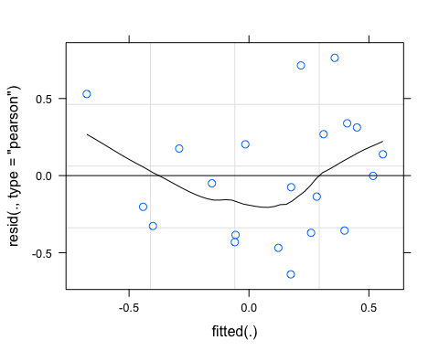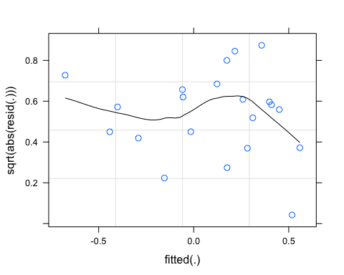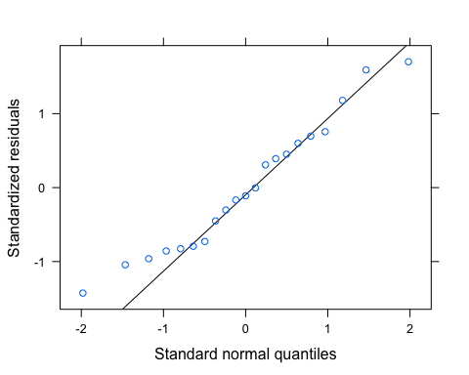 let me log transform to see if its better:

# log transform   
fDOM_data_year$logmeanBETA <- log(abs(fDOM_data_year$meanBETA))  
  
BETA.fDOM.year.log <- lmer(logmeanBETA ~ CatPF*pctburn_lg + (1|year),   
 data = fDOM_data_year)

## boundary (singular) fit: see ?isSingular

summary(BETA.fDOM.year.log)

## Linear mixed model fit by REML ['lmerMod']  
## Formula: logmeanBETA ~ CatPF * pctburn_lg + (1 | year)  
## Data: fDOM_data_year  
##   
## REML criterion at convergence: 55.3  
##   
## Scaled residuals:   
## Min 1Q Median 3Q Max   
## -2.3233 -0.6495 0.3404 0.6602 1.2354   
##   
## Random effects:  
## Groups Name Variance Std.Dev.  
## year (Intercept) 0.0000 0.0000   
## Residual 0.8839 0.9402   
## Number of obs: 21, groups: year, 4  
##   
## Fixed effects:  
## Estimate Std. Error t value  
## (Intercept) -0.92886 0.38963 -2.384  
## CatPFmedium -0.25381 0.45934 -0.553  
## pctburn_lg -0.03912 0.33057 -0.118  
## CatPFmedium:pctburn_lg -0.24042 0.42399 -0.567  
##   
## Correlation of Fixed Effects:  
## (Intr) CtPFmd pctbr_  
## CatPFmedium -0.848   
## pctburn_lg -0.172 0.146   
## CtPFmdm:pc_ 0.134 -0.092 -0.780  
## optimizer (nloptwrap) convergence code: 0 (OK)  
## boundary (singular) fit: see ?isSingular

vif(BETA.fDOM.year.log)

## CatPF pctburn_lg CatPF:pctburn_lg   
## 1.023000 2.586499 2.553152

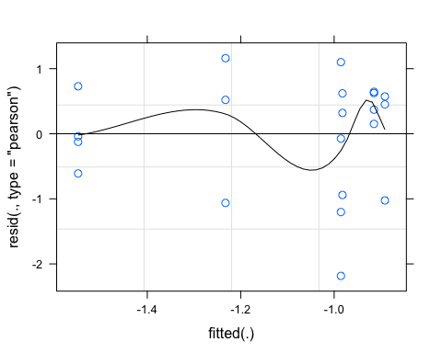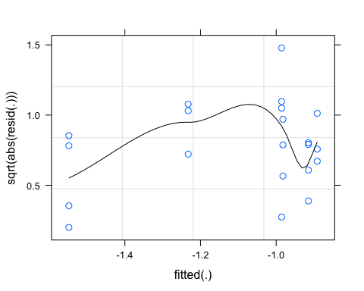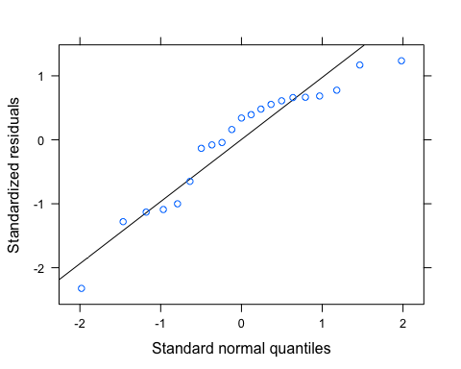 this looks worse TBH

pr <- ggpredict(BETA.fDOM.year)  
plot(pr, add.data = TRUE)

## $CatPF

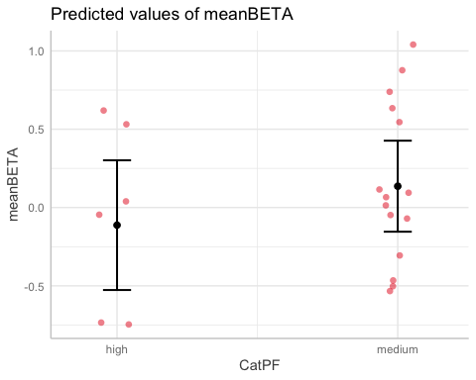

##   
## $pctburn_lg

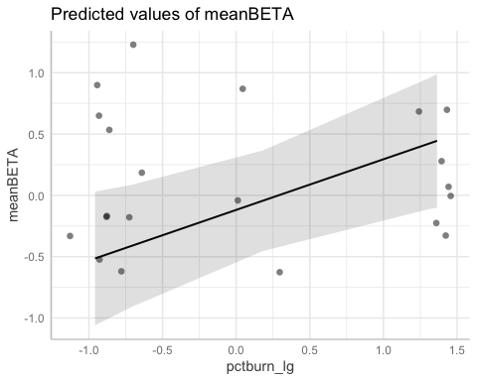

ggplot(fDOM_data_year, aes(x = pctburn_lg, y = meanBETA, color = CatPF)) +  
 geom_point() +  
 geom_smooth(method = "lm", na.rm = TRUE, fullrange = TRUE, aes(group = CatPF)) +  
 stat_poly_eq(formula = y~x,  
 label.y = "top", label.x = "right",  
 aes(label = paste(..eq.label.., ..rr.label.., sep = "~~~")),   
 parse = TRUE) +   
 theme_classic()

## `geom_smooth()` using formula 'y ~ x'

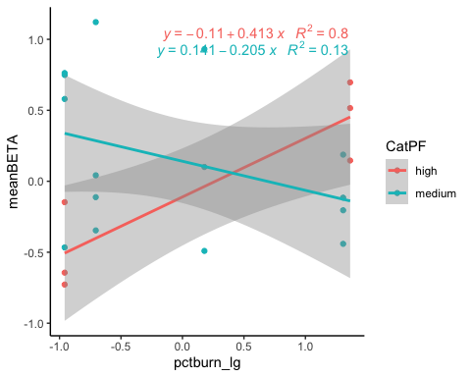

# CVHI model

CVhi.fDOM.year <- lmer(CVhi ~ CatPF*pctburn_lg + (1|year),   
 data = fDOM_data_year)  
summary(CVhi.fDOM.year)

## Linear mixed model fit by REML ['lmerMod']  
## Formula: CVhi ~ CatPF * pctburn_lg + (1 | year)  
## Data: fDOM_data_year  
##   
## REML criterion at convergence: 90.3  
##   
## Scaled residuals:   
## Min 1Q Median 3Q Max   
## -2.0103 -0.4032 0.0069 0.1377 2.3119   
##   
## Random effects:  
## Groups Name Variance Std.Dev.  
## year (Intercept) 0.07342 0.271   
## Residual 6.87920 2.623   
## Number of obs: 21, groups: year, 4  
##   
## Fixed effects:  
## Estimate Std. Error t value  
## (Intercept) 2.3843 1.0981 2.171  
## CatPFmedium -3.7251 1.2829 -2.904  
## pctburn_lg -2.5001 0.9222 -2.711  
## CatPFmedium:pctburn_lg 2.1670 1.1828 1.832  
##   
## Correlation of Fixed Effects:  
## (Intr) CtPFmd pctbr_  
## CatPFmedium -0.842   
## pctburn_lg -0.170 0.146   
## CtPFmdm:pc_ 0.133 -0.092 -0.780

vif(CVhi.fDOM.year)

## CatPF pctburn_lg CatPF:pctburn_lg   
## 1.022926 2.586223 2.553040

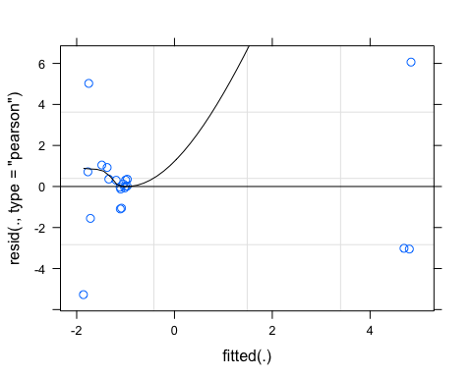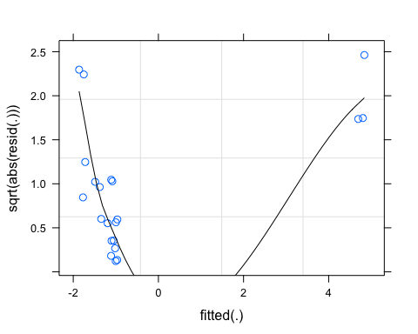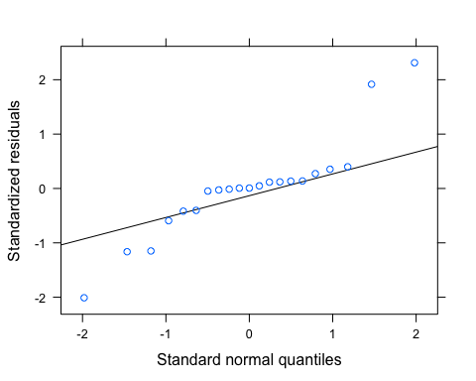 Lets log transform

#log transform   
fDOM_data_year$logCVhi <- log(abs(fDOM_data_year$CVhi))  
CVhi.fDOM.year.log <- lmer(logCVhi ~ CatPF*pctburn_lg + (1|year),   
 data = fDOM_data_year)

## boundary (singular) fit: see ?isSingular

summary(CVhi.fDOM.year.log) # year is adding NO variance

## Linear mixed model fit by REML ['lmerMod']  
## Formula: logCVhi ~ CatPF * pctburn_lg + (1 | year)  
## Data: fDOM_data_year  
##   
## REML criterion at convergence: 46.6  
##   
## Scaled residuals:   
## Min 1Q Median 3Q Max   
## -1.57792 -0.49553 -0.06999 0.53965 1.69110   
##   
## Random effects:  
## Groups Name Variance Std.Dev.  
## year (Intercept) 0.0000 0.0000   
## Residual 0.5311 0.7288   
## Number of obs: 21, groups: year, 4  
##   
## Fixed effects:  
## Estimate Std. Error t value  
## (Intercept) 0.6891 0.3020 2.282  
## CatPFmedium -0.4304 0.3560 -1.209  
## pctburn_lg -0.4877 0.2562 -1.903  
## CatPFmedium:pctburn_lg 0.8961 0.3287 2.727  
##   
## Correlation of Fixed Effects:  
## (Intr) CtPFmd pctbr_  
## CatPFmedium -0.848   
## pctburn_lg -0.172 0.146   
## CtPFmdm:pc_ 0.134 -0.092 -0.780  
## optimizer (nloptwrap) convergence code: 0 (OK)  
## boundary (singular) fit: see ?isSingular

# pctburn_lg is more significant on its own  
# interaction has the highest t-value   
  
vif(CVhi.fDOM.year.log)

## CatPF pctburn_lg CatPF:pctburn_lg   
## 1.023000 2.586499 2.553152

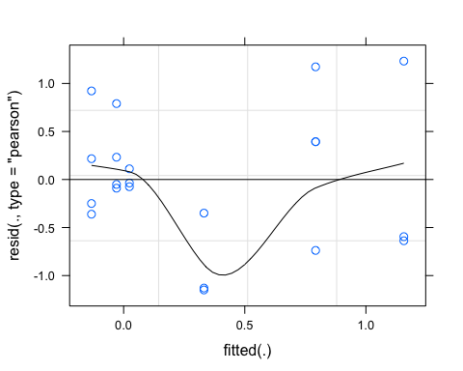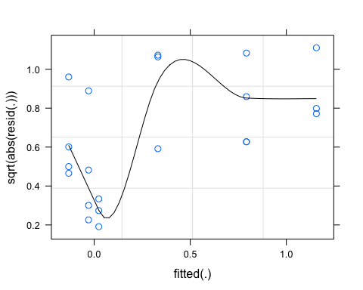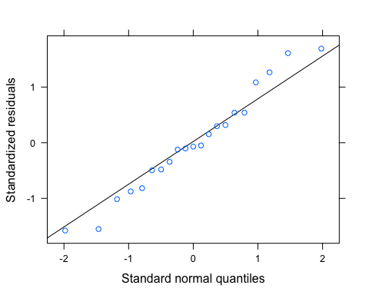 this looks better, lets interpret this:

pr <- ggpredict(CVhi.fDOM.year.log)  
plot(pr, add.data = TRUE)

## $CatPF

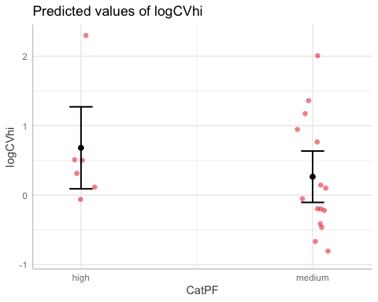

##   
## $pctburn_lg

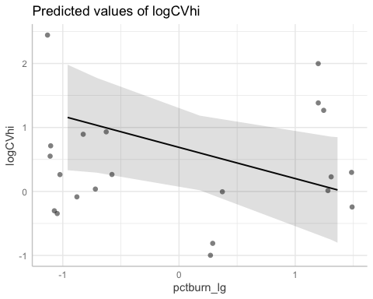

ggplot(fDOM_data_year, aes(x = pctburn_lg, y = CVhi, color = CatPF)) +  
 geom_point() +  
 geom_smooth(method = "lm", na.rm = TRUE, fullrange = TRUE, aes(group = CatPF)) +  
 stat_poly_eq(formula = y~x,  
 label.y = "top", label.x = "right",  
 aes(label = paste(..eq.label.., ..rr.label.., sep = "~~~")),   
 parse = TRUE) +   
 theme_classic()

## `geom_smooth()` using formula 'y ~ x'

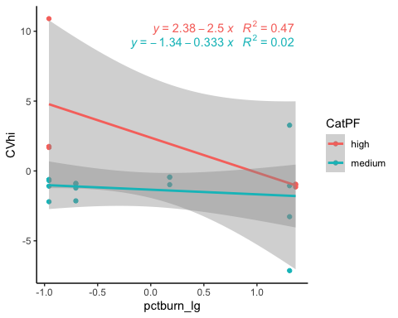

CVhi.fDOM <- lm(CVhi ~ CatPF*pctburn_lg,   
 data = fDOM_data)  
summary(CVhi.fDOM) # nothing is significant

##   
## Call:  
## lm(formula = CVhi ~ CatPF * pctburn_lg, data = fDOM_data)  
##   
## Residuals:  
## 1 2 3 4 5 6   
## -5.050e-01 -2.363e-01 -6.938e-01 1.435e+00 3.886e-16 -5.551e-16   
##   
## Coefficients:  
## Estimate Std. Error t value Pr(>|t|)  
## (Intercept) 2.491420 1.194107 2.086 0.172  
## CatPFmedium -2.985400 1.469899 -2.031 0.179  
## pctburn_lg -0.052413 0.025074 -2.090 0.172  
## CatPFmedium:pctburn_lg 0.006259 0.034164 0.183 0.872  
##   
## Residual standard error: 1.194 on 2 degrees of freedom  
## Multiple R-squared: 0.8743, Adjusted R-squared: 0.6857   
## F-statistic: 4.636 on 3 and 2 DF, p-value: 0.1825

plot(CVhi.fDOM)

## Warning: not plotting observations with leverage one:  
## 5, 6

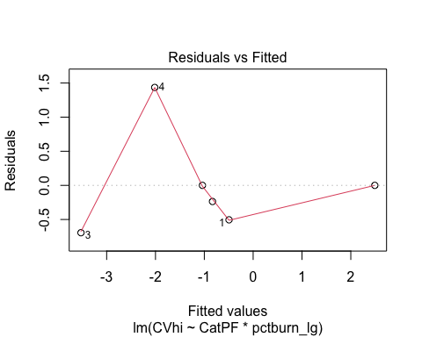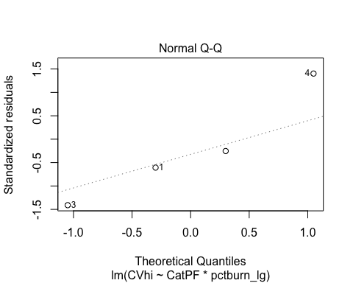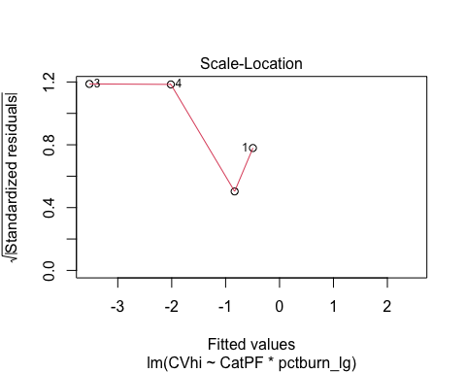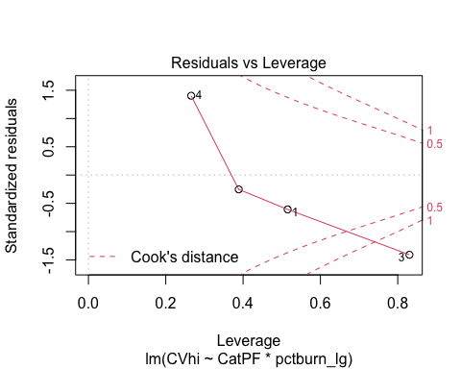

# CVBETA model - year

CVbeta.fDOM.year <- lmer(CVbeta ~ CatPF*pctburn_lg + (1|year),   
 data = fDOM_data_year)  
summary(CVbeta.fDOM.year)

## Linear mixed model fit by REML ['lmerMod']  
## Formula: CVbeta ~ CatPF * pctburn_lg + (1 | year)  
## Data: fDOM_data_year  
##   
## REML criterion at convergence: 122.2  
##   
## Scaled residuals:   
## Min 1Q Median 3Q Max   
## -2.1627 -0.3398 -0.1612 0.2133 2.2827   
##   
## Random effects:  
## Groups Name Variance Std.Dev.  
## year (Intercept) 13.90 3.729   
## Residual 37.87 6.154   
## Number of obs: 21, groups: year, 4  
##   
## Fixed effects:  
## Estimate Std. Error t value  
## (Intercept) -1.035 3.242 -0.319  
## CatPFmedium 1.273 3.062 0.416  
## pctburn_lg 2.873 2.164 1.328  
## CatPFmedium:pctburn_lg -3.518 2.775 -1.267  
##   
## Correlation of Fixed Effects:  
## (Intr) CtPFmd pctbr_  
## CatPFmedium -0.698   
## pctburn_lg -0.135 0.143   
## CtPFmdm:pc_ 0.109 -0.093 -0.780

vif(CVbeta.fDOM.year)

## CatPF pctburn_lg CatPF:pctburn_lg   
## 1.021853 2.582145 2.551407

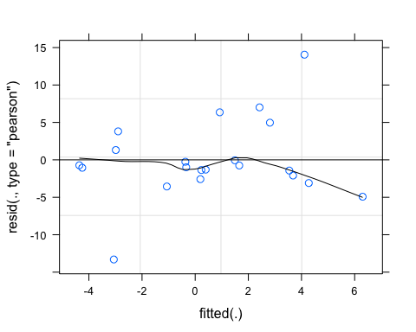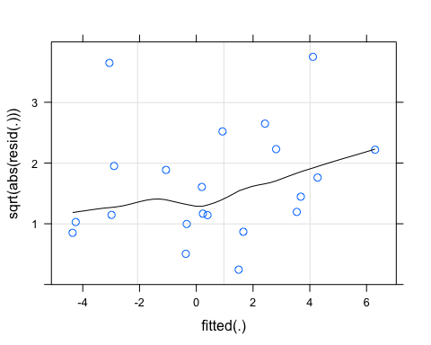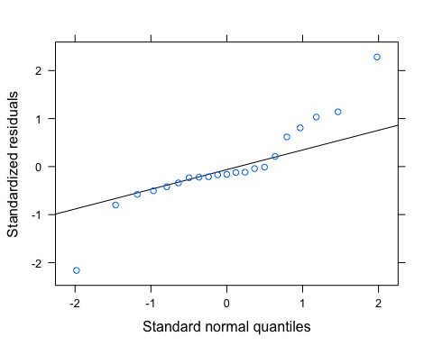 Let me log transform

# log transform  
fDOM_data_year$logCVbeta <- log(abs(fDOM_data_year$CVbeta))  
  
CVbeta.fDOM.year.log <- lmer(logCVbeta ~ CatPF*pctburn_lg + (1|year),   
 data = fDOM_data_year)

## boundary (singular) fit: see ?isSingular

summary(CVbeta.fDOM.year.log) # year adds 0 variance and nothing is really explaining it here

## Linear mixed model fit by REML ['lmerMod']  
## Formula: logCVbeta ~ CatPF * pctburn_lg + (1 | year)  
## Data: fDOM_data_year  
##   
## REML criterion at convergence: 58.5  
##   
## Scaled residuals:   
## Min 1Q Median 3Q Max   
## -1.0077 -0.6794 -0.3713 0.4653 2.0865   
##   
## Random effects:  
## Groups Name Variance Std.Dev.  
## year (Intercept) 0.000 0.000   
## Residual 1.067 1.033   
## Number of obs: 21, groups: year, 4  
##   
## Fixed effects:  
## Estimate Std. Error t value  
## (Intercept) 0.7527 0.4281 1.758  
## CatPFmedium 0.2810 0.5047 0.557  
## pctburn_lg 0.1887 0.3632 0.520  
## CatPFmedium:pctburn_lg 0.2223 0.4658 0.477  
##   
## Correlation of Fixed Effects:  
## (Intr) CtPFmd pctbr_  
## CatPFmedium -0.848   
## pctburn_lg -0.172 0.146   
## CtPFmdm:pc_ 0.134 -0.092 -0.780  
## optimizer (nloptwrap) convergence code: 0 (OK)  
## boundary (singular) fit: see ?isSingular

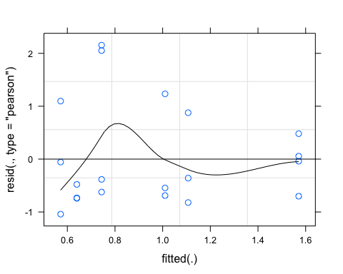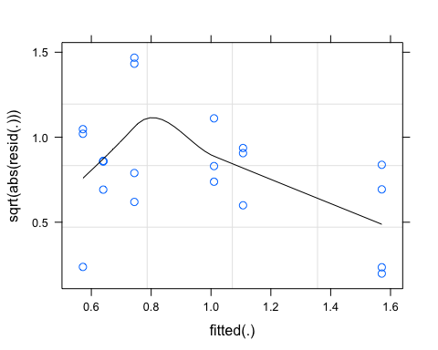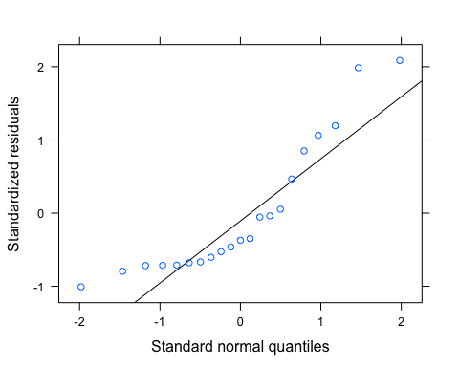 This still doesnt look great

pr <- ggpredict(CVbeta.fDOM.year.log)  
plot(pr, add.data = TRUE)

## $CatPF

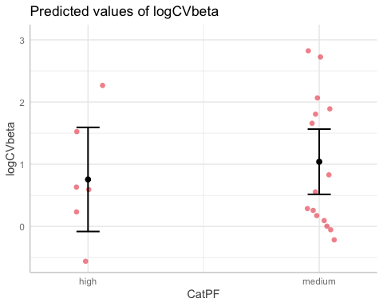

##   
## $pctburn_lg

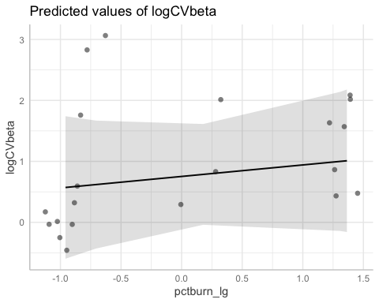

ggplot(fDOM_data_year, aes(x = pctburn_lg, y = CVbeta, color = CatPF)) +  
 geom_point() +  
 geom_smooth(method = "lm", na.rm = TRUE, fullrange = TRUE, aes(group = CatPF)) +  
 stat_poly_eq(formula = y~x,  
 label.y = "top", label.x = "right",  
 aes(label = paste(..eq.label.., ..rr.label.., sep = "~~~")),   
 parse = TRUE) +   
 theme_classic()

## `geom_smooth()` using formula 'y ~ x'

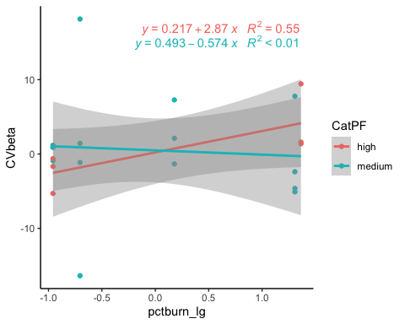

CVbeta.fDOM <- lm(logCVbeta ~ CatPF*pctburn_lg,   
 data = fDOM_data_year)  
summary(CVbeta.fDOM) # nothing is significant

##   
## Call:  
## lm(formula = logCVbeta ~ CatPF * pctburn_lg, data = fDOM_data_year)  
##   
## Residuals:  
## Min 1Q Median 3Q Max   
## -1.0410 -0.7018 -0.3835 0.4806 2.1553   
##   
## Coefficients:  
## Estimate Std. Error t value Pr(>|t|)   
## (Intercept) 0.7527 0.4281 1.758 0.0967 .  
## CatPFmedium 0.2810 0.5047 0.557 0.5849   
## pctburn_lg 0.1887 0.3632 0.520 0.6100   
## CatPFmedium:pctburn_lg 0.2223 0.4658 0.477 0.6394   
## ---  
## Signif. codes: 0 '***' 0.001 '**' 0.01 '*' 0.05 '.' 0.1 ' ' 1  
##   
## Residual standard error: 1.033 on 17 degrees of freedom  
## Multiple R-squared: 0.1258, Adjusted R-squared: -0.02848   
## F-statistic: 0.8154 on 3 and 17 DF, p-value: 0.503

plot(CVbeta.fDOM)

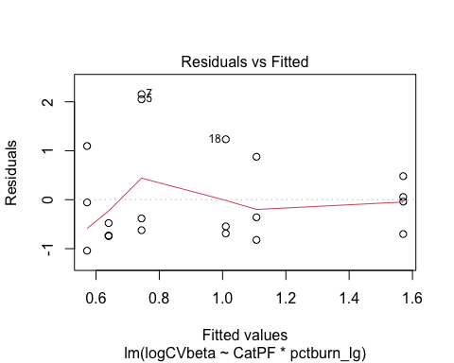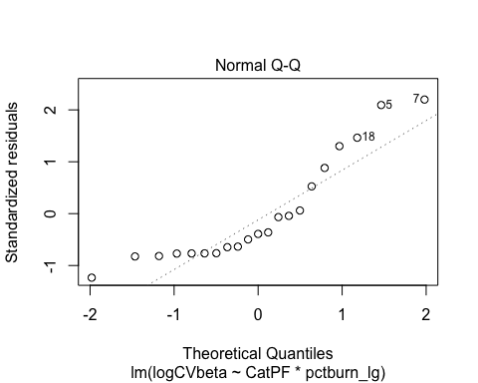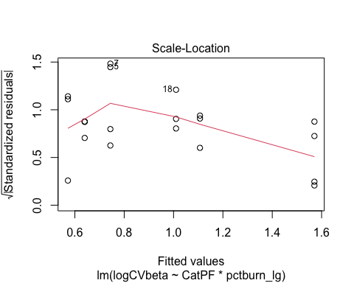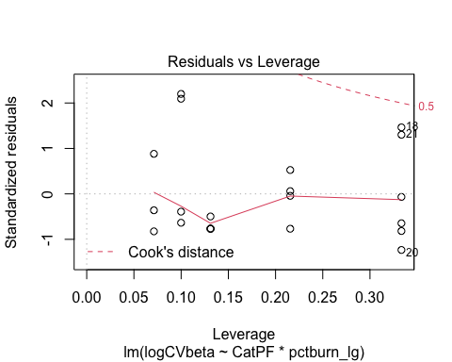

# SPC

SPC_data_year<- CV_all_year_SPC[,c("site.ID", "year", "meanHI", "meanBETA", "CVhi", "CVbeta", "Slope", "fireyear_lg", "pctburn_lg", "areaburn_lg", "PF", "NDVI", "CatBurn", "CatPF")]  
  
SPC_data<- CV_all_SPC[,c("site.ID", "meanHI", "meanBETA", "CVhi", "CVbeta", "Slope", "fireyear_lg", "pctburn_lg", "areaburn_lg", "PF", "NDVI", "CatBurn", "CatPF")]  
  
ggpairs(SPC_data_year,  
 columns = c("meanHI","Slope", "pctburn_lg", "PF"),  
 ggplot2::aes(colour = site.ID))

## Warning in cor(x, y): the standard deviation is zero  
  
## Warning in cor(x, y): the standard deviation is zero  
  
## Warning in cor(x, y): the standard deviation is zero  
  
## Warning in cor(x, y): the standard deviation is zero  
  
## Warning in cor(x, y): the standard deviation is zero  
  
## Warning in cor(x, y): the standard deviation is zero  
  
## Warning in cor(x, y): the standard deviation is zero  
  
## Warning in cor(x, y): the standard deviation is zero  
  
## Warning in cor(x, y): the standard deviation is zero  
  
## Warning in cor(x, y): the standard deviation is zero  
  
## Warning in cor(x, y): the standard deviation is zero  
  
## Warning in cor(x, y): the standard deviation is zero  
  
## Warning in cor(x, y): the standard deviation is zero  
  
## Warning in cor(x, y): the standard deviation is zero  
  
## Warning in cor(x, y): the standard deviation is zero  
  
## Warning in cor(x, y): the standard deviation is zero  
  
## Warning in cor(x, y): the standard deviation is zero  
  
## Warning in cor(x, y): the standard deviation is zero  
  
## Warning in cor(x, y): the standard deviation is zero  
  
## Warning in cor(x, y): the standard deviation is zero  
  
## Warning in cor(x, y): the standard deviation is zero  
  
## Warning in cor(x, y): the standard deviation is zero  
  
## Warning in cor(x, y): the standard deviation is zero  
  
## Warning in cor(x, y): the standard deviation is zero  
  
## Warning in cor(x, y): the standard deviation is zero  
  
## Warning in cor(x, y): the standard deviation is zero  
  
## Warning in cor(x, y): the standard deviation is zero  
  
## Warning in cor(x, y): the standard deviation is zero  
  
## Warning in cor(x, y): the standard deviation is zero  
  
## Warning in cor(x, y): the standard deviation is zero  
  
## Warning in cor(x, y): the standard deviation is zero  
  
## Warning in cor(x, y): the standard deviation is zero  
  
## Warning in cor(x, y): the standard deviation is zero

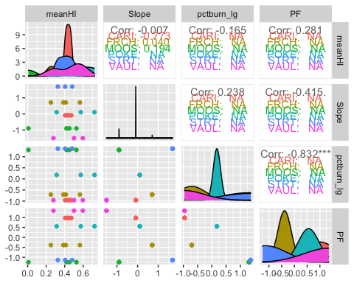

# ggsave("pairs1.pdf",  
# width = 10, height = 10)

# HI model - year

HI.SPC.year <- lmer(meanHI ~ CatPF*pctburn_lg + (1|year),   
 data = SPC_data_year)  
summary(HI.SPC.year) # year is adding to the variance

## Linear mixed model fit by REML ['lmerMod']  
## Formula: meanHI ~ CatPF * pctburn_lg + (1 | year)  
## Data: SPC_data_year  
##   
## REML criterion at convergence: -6.9  
##   
## Scaled residuals:   
## Min 1Q Median 3Q Max   
## -2.20870 -0.32136 -0.02007 0.63521 1.91669   
##   
## Random effects:  
## Groups Name Variance Std.Dev.  
## year (Intercept) 0.005203 0.07213   
## Residual 0.019745 0.14052   
## Number of obs: 21, groups: year, 4  
##   
## Fixed effects:  
## Estimate Std. Error t value  
## (Intercept) 0.432736 0.070195 6.165  
## CatPFmedium -0.009397 0.069731 -0.135  
## pctburn_lg -0.023390 0.049406 -0.473  
## CatPFmedium:pctburn_lg -0.001885 0.063376 -0.030  
##   
## Correlation of Fixed Effects:  
## (Intr) CtPFmd pctbr_  
## CatPFmedium -0.731   
## pctburn_lg -0.143 0.144   
## CtPFmdm:pc_ 0.114 -0.093 -0.780

# nothing is really explaining anything here   
  
vif(HI.SPC.year)

## CatPF pctburn_lg CatPF:pctburn_lg   
## 1.022021 2.582791 2.551663

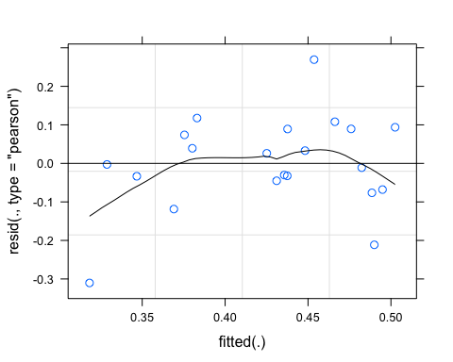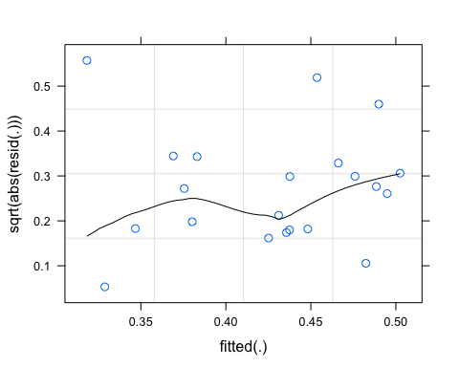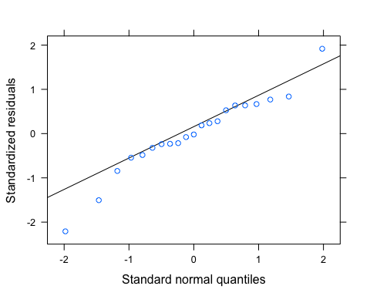 residuals arent the best….log transforming makes it worse

pr <- ggpredict(HI.SPC.year)  
plot(pr, add.data = TRUE)

## $CatPF

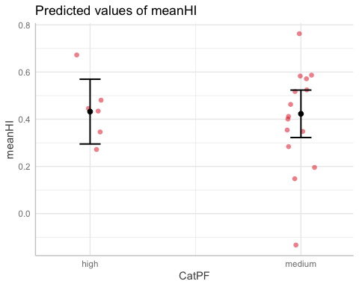

##   
## $pctburn_lg

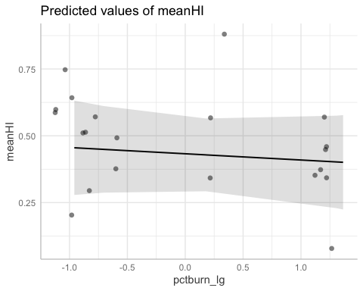

ggplot(SPC_data_year, aes(x = pctburn_lg, y = meanHI, color = CatPF)) +  
 geom_point() +  
 geom_smooth(method = "lm", na.rm = TRUE, fullrange = TRUE, aes(group = CatPF)) +  
 stat_poly_eq(formula = y~x,  
 label.y = "top", label.x = "right",  
 aes(label = paste(..eq.label.., ..rr.label.., sep = "~~~")),   
 parse = TRUE) +   
 theme_classic()

## `geom_smooth()` using formula 'y ~ x'

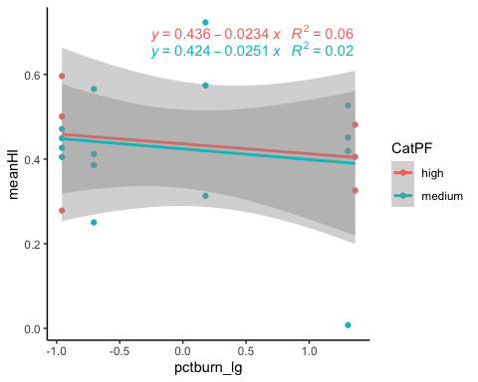

# BETA model

BETA.SPC.year <- lmer(meanBETA ~ CatPF*pctburn_lg + (1|year),   
 data = SPC_data_year)  
summary(BETA.SPC.year)

## Linear mixed model fit by REML ['lmerMod']  
## Formula: meanBETA ~ CatPF * pctburn_lg + (1 | year)  
## Data: SPC_data_year  
##   
## REML criterion at convergence: 75.6  
##   
## Scaled residuals:   
## Min 1Q Median 3Q Max   
## -3.1759 -0.3371 0.1945 0.5141 1.1337   
##   
## Random effects:  
## Groups Name Variance Std.Dev.  
## year (Intercept) 0.1958 0.4425   
## Residual 2.7702 1.6644   
## Number of obs: 21, groups: year, 4  
##   
## Fixed effects:  
## Estimate Std. Error t value  
## (Intercept) -0.58649 0.73351 -0.800  
## CatPFmedium 0.07222 0.81834 0.088  
## pctburn_lg -0.26525 0.58520 -0.453  
## CatPFmedium:pctburn_lg -0.31044 0.75063 -0.414  
##   
## Correlation of Fixed Effects:  
## (Intr) CtPFmd pctbr_  
## CatPFmedium -0.810   
## pctburn_lg -0.162 0.145   
## CtPFmdm:pc_ 0.128 -0.093 -0.780

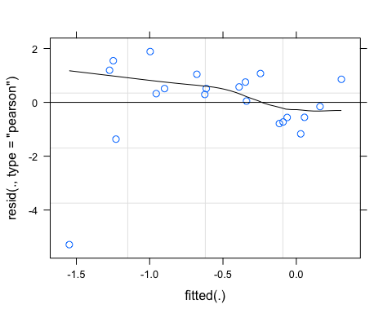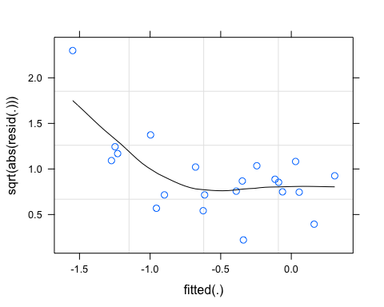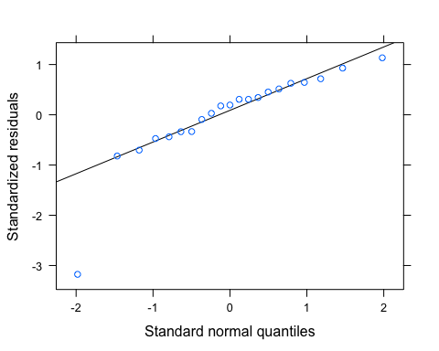 one point is making this meh…let me log transform

# log transform   
SPC_data_year$logmeanBETA <- log(abs(SPC_data_year$meanBETA))  
  
BETA.SPC.year.log <- lmer(logmeanBETA ~ CatPF*pctburn_lg + (1|year),   
 data = SPC_data_year)

## boundary (singular) fit: see ?isSingular

summary(BETA.SPC.year.log) # year is adding 0 variance

## Linear mixed model fit by REML ['lmerMod']  
## Formula: logmeanBETA ~ CatPF * pctburn_lg + (1 | year)  
## Data: SPC_data_year  
##   
## REML criterion at convergence: 70.4  
##   
## Scaled residuals:   
## Min 1Q Median 3Q Max   
## -2.82667 -0.38585 0.06447 0.56303 1.74499   
##   
## Random effects:  
## Groups Name Variance Std.Dev.  
## year (Intercept) 0.000 0.000   
## Residual 2.157 1.469   
## Number of obs: 21, groups: year, 4  
##   
## Fixed effects:  
## Estimate Std. Error t value  
## (Intercept) -0.85270 0.60870 -1.401  
## CatPFmedium 0.02404 0.71759 0.033  
## pctburn_lg 0.49935 0.51642 0.967  
## CatPFmedium:pctburn_lg -0.35579 0.66237 -0.537  
##   
## Correlation of Fixed Effects:  
## (Intr) CtPFmd pctbr_  
## CatPFmedium -0.848   
## pctburn_lg -0.172 0.146   
## CtPFmdm:pc_ 0.134 -0.092 -0.780  
## optimizer (nloptwrap) convergence code: 0 (OK)  
## boundary (singular) fit: see ?isSingular

# nothing is really explaining this here

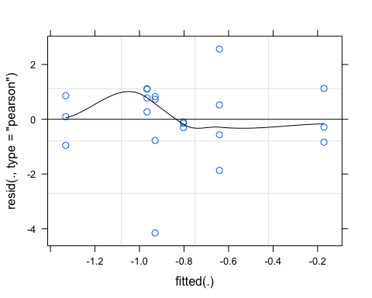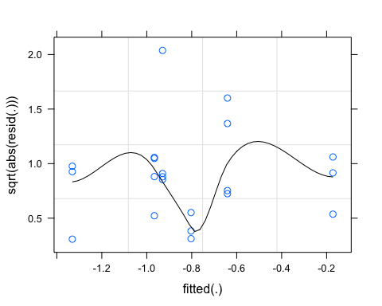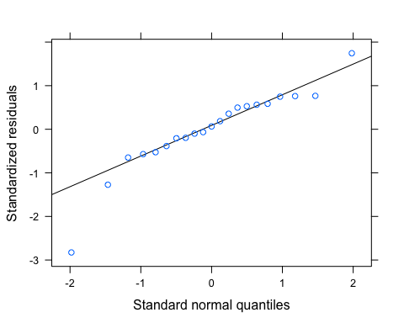

pr <- ggpredict(BETA.SPC.year.log)  
plot(pr, add.data = TRUE)

## $CatPF

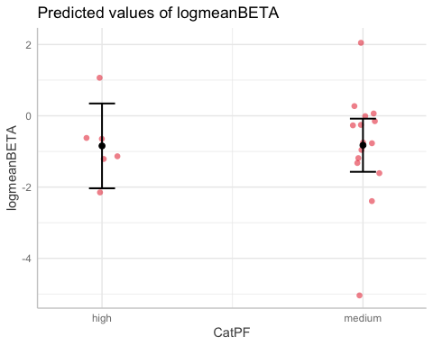

##   
## $pctburn_lg

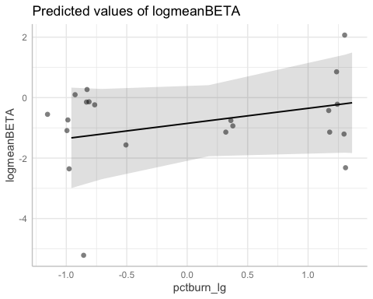

ggplot(SPC_data_year, aes(x = pctburn_lg, y = meanBETA, color = CatPF)) +  
 geom_point() +  
 geom_smooth(method = "lm", na.rm = TRUE, fullrange = TRUE, aes(group = CatPF)) +  
 stat_poly_eq(formula = y~x,  
 label.y = "top", label.x = "right",  
 aes(label = paste(..eq.label.., ..rr.label.., sep = "~~~")),   
 parse = TRUE) +   
 theme_classic()

## `geom_smooth()` using formula 'y ~ x'

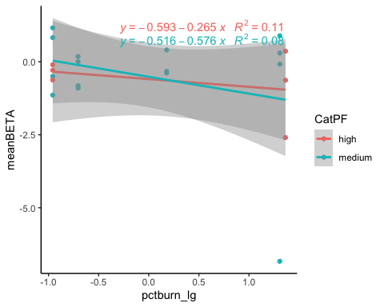

BETA.SPC <- lm(meanBETA ~ CatPF*pctburn_lg,   
 data = SPC_data_year)  
summary(BETA.SPC) # year is adding 0 variance

##   
## Call:  
## lm(formula = meanBETA ~ CatPF * pctburn_lg, data = SPC_data_year)  
##   
## Residuals:  
## Min 1Q Median 3Q Max   
## -5.5657 -0.5365 0.2366 1.0248 2.1587   
##   
## Coefficients:  
## Estimate Std. Error t value Pr(>|t|)  
## (Intercept) -0.59266 0.71193 -0.832 0.417  
## CatPFmedium 0.07714 0.83929 0.092 0.928  
## pctburn_lg -0.26525 0.60401 -0.439 0.666  
## CatPFmedium:pctburn_lg -0.31080 0.77471 -0.401 0.693  
##   
## Residual standard error: 1.718 on 17 degrees of freedom  
## Multiple R-squared: 0.0881, Adjusted R-squared: -0.07283   
## F-statistic: 0.5474 on 3 and 17 DF, p-value: 0.6566

# nothing is really explaining this here   
plot(BETA.SPC)

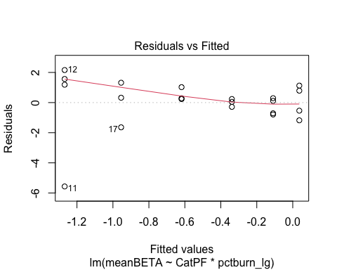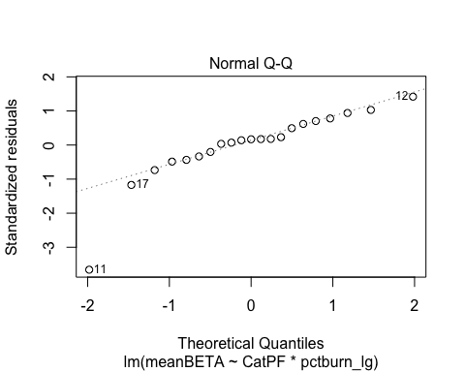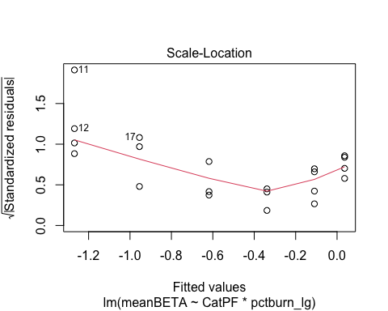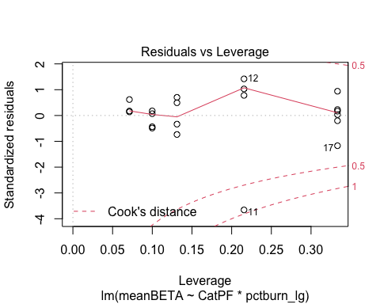

# CVHI model

SPC_data_year$logCVhi <- log(abs(SPC_data_year$CVhi))  
  
CVhi.SPC.year.log <- lmer(CVhi ~ CatPF*pctburn_lg + (1|year),   
 data = SPC_data_year)  
summary(CVhi.SPC.year.log) # year is adding to variance

## Linear mixed model fit by REML ['lmerMod']  
## Formula: CVhi ~ CatPF * pctburn_lg + (1 | year)  
## Data: SPC_data_year  
##   
## REML criterion at convergence: 148.6  
##   
## Scaled residuals:   
## Min 1Q Median 3Q Max   
## -0.9992 -0.4373 0.0111 0.0613 3.6197   
##   
## Random effects:  
## Groups Name Variance Std.Dev.  
## year (Intercept) 4.281 2.069   
## Residual 210.037 14.493   
## Number of obs: 21, groups: year, 4  
##   
## Fixed effects:  
## Estimate Std. Error t value  
## (Intercept) 1.006011 6.122066 0.164  
## CatPFmedium 4.800684 7.095665 0.677  
## pctburn_lg 0.002087 5.095687 0.000  
## CatPFmedium:pctburn_lg 7.440739 6.535940 1.138  
##   
## Correlation of Fixed Effects:  
## (Intr) CtPFmd pctbr_  
## CatPFmedium -0.837   
## pctburn_lg -0.169 0.146   
## CtPFmdm:pc_ 0.132 -0.092 -0.780

# nothing is really explaining this here   
  
vif(CVhi.SPC.year.log)

## CatPF pctburn_lg CatPF:pctburn_lg   
## 1.022863 2.585988 2.552945

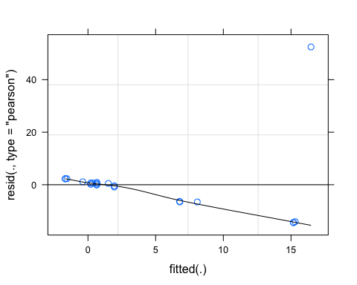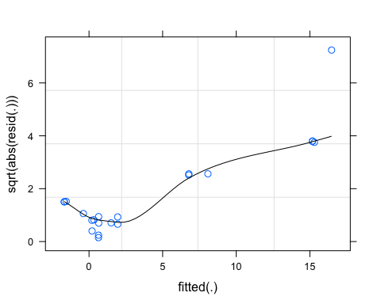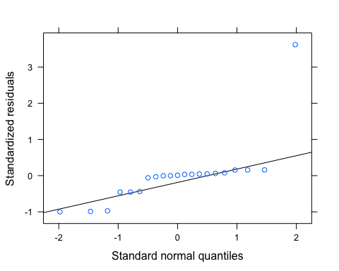 One point is really out of whack

pr <- ggpredict(CVhi.SPC.year.log)  
plot(pr, add.data = TRUE)

## $CatPF

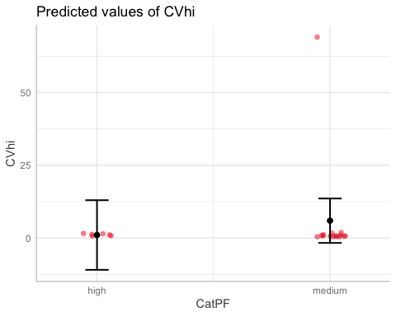

##   
## $pctburn_lg

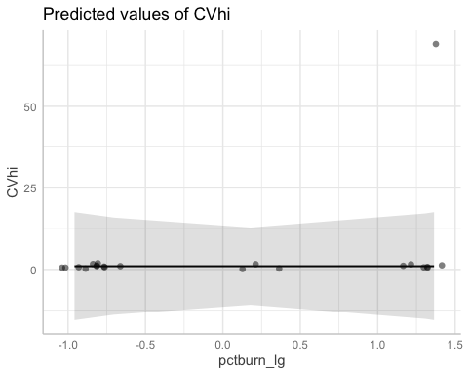

ggplot(SPC_data_year, aes(x = pctburn_lg, y = CVhi, color = CatPF)) +  
 geom_point() +  
 geom_smooth(method = "lm", na.rm = TRUE, fullrange = TRUE, aes(group = CatPF)) +  
 stat_poly_eq(formula = y~x,  
 label.y = "top", label.x = "right",  
 aes(label = paste(..eq.label.., ..rr.label.., sep = "~~~")),   
 parse = TRUE) +   
 theme_classic()

## `geom_smooth()` using formula 'y ~ x'

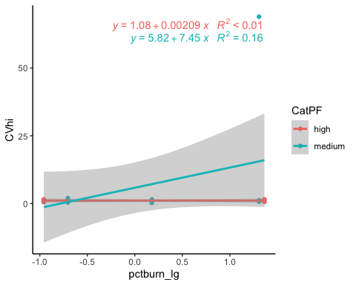

# CVBETA model

# log transform   
SPC_data_year$logCVbeta <- log(abs(SPC_data_year$CVbeta))  
CVbeta.SPC.year.log <- lmer(logCVbeta ~ CatPF*pctburn_lg + (1|year),   
 data = SPC_data_year)

## boundary (singular) fit: see ?isSingular

summary(CVbeta.SPC.year.log) # year is adding 0 variance

## Linear mixed model fit by REML ['lmerMod']  
## Formula: logCVbeta ~ CatPF * pctburn_lg + (1 | year)  
## Data: SPC_data_year  
##   
## REML criterion at convergence: 64.9  
##   
## Scaled residuals:   
## Min 1Q Median 3Q Max   
## -1.1259 -0.5788 -0.3099 0.5873 2.8504   
##   
## Random effects:  
## Groups Name Variance Std.Dev.  
## year (Intercept) 0.000 0.000   
## Residual 1.561 1.249   
## Number of obs: 21, groups: year, 4  
##   
## Fixed effects:  
## Estimate Std. Error t value  
## (Intercept) 1.02221 0.51772 1.974  
## CatPFmedium 0.08868 0.61034 0.145  
## pctburn_lg -0.39509 0.43923 -0.900  
## CatPFmedium:pctburn_lg 0.59270 0.56337 1.052  
##   
## Correlation of Fixed Effects:  
## (Intr) CtPFmd pctbr_  
## CatPFmedium -0.848   
## pctburn_lg -0.172 0.146   
## CtPFmdm:pc_ 0.134 -0.092 -0.780  
## optimizer (nloptwrap) convergence code: 0 (OK)  
## boundary (singular) fit: see ?isSingular

# nothing is really explaining anything really   
  
vif(CVbeta.SPC.year.log)

## CatPF pctburn_lg CatPF:pctburn_lg   
## 1.023000 2.586499 2.553152

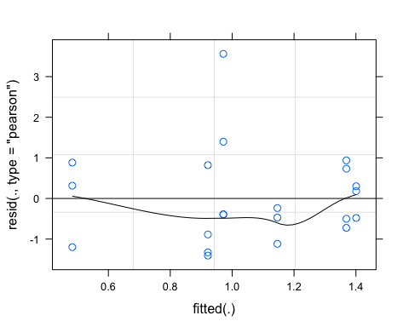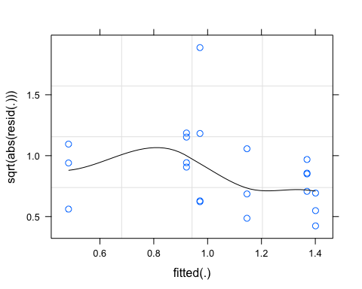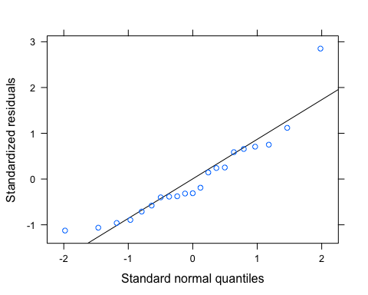

CVbeta.SPC <- lm(logCVbeta ~ CatPF*pctburn_lg,   
 data = SPC_data_year)  
summary(CVbeta.SPC) # year is adding 0 variance

##   
## Call:  
## lm(formula = logCVbeta ~ CatPF * pctburn_lg, data = SPC_data_year)  
##   
## Residuals:  
## Min 1Q Median 3Q Max   
## -1.4065 -0.7231 -0.3871 0.7337 3.5608   
##   
## Coefficients:  
## Estimate Std. Error t value Pr(>|t|)   
## (Intercept) 1.02221 0.51772 1.974 0.0648 .  
## CatPFmedium 0.08868 0.61034 0.145 0.8862   
## pctburn_lg -0.39509 0.43923 -0.900 0.3810   
## CatPFmedium:pctburn_lg 0.59270 0.56337 1.052 0.3075   
## ---  
## Signif. codes: 0 '***' 0.001 '**' 0.01 '*' 0.05 '.' 0.1 ' ' 1  
##   
## Residual standard error: 1.249 on 17 degrees of freedom  
## Multiple R-squared: 0.06545, Adjusted R-squared: -0.09947   
## F-statistic: 0.3969 on 3 and 17 DF, p-value: 0.7569

# nothing is really explaining anything really  
  
plot(CVbeta.SPC)

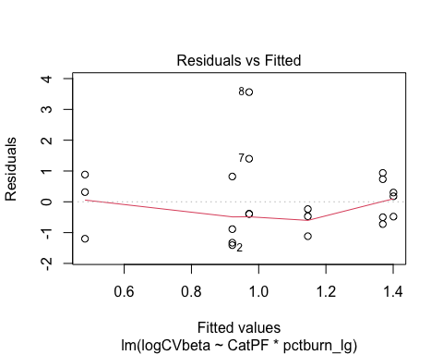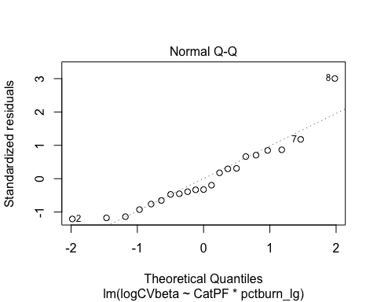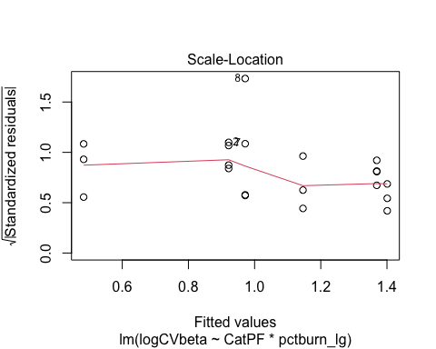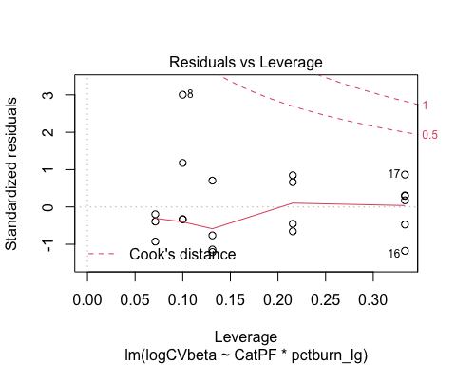

pr <- ggpredict(CVbeta.SPC.year.log)  
plot(pr, add.data = TRUE)

## $CatPF

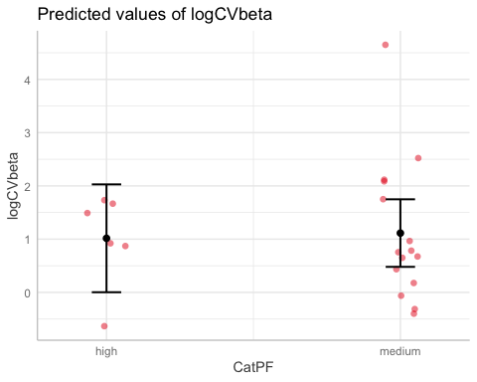

##   
## $pctburn_lg

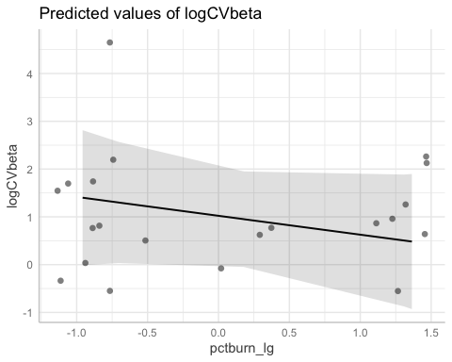

ggplot(SPC_data_year, aes(x = pctburn_lg, y = CVbeta, color = CatPF)) +  
 geom_point() +  
 geom_smooth(method = "lm", na.rm = TRUE, fullrange = TRUE, aes(group = CatPF)) +  
 stat_poly_eq(formula = y~x,  
 label.y = "top", label.x = "right",  
 aes(label = paste(..eq.label.., ..rr.label.., sep = "~~~")),   
 parse = TRUE) +   
 theme_classic()

## `geom_smooth()` using formula 'y ~ x'

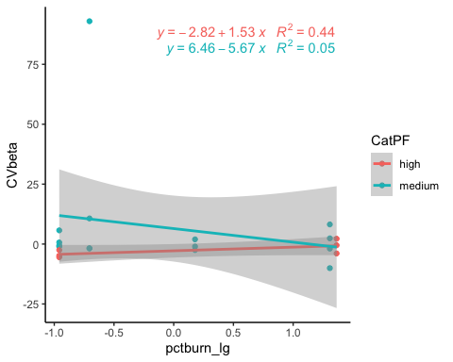

# turb

turb_data_year<- CV_all_year_turb[,c("site.ID", "year", "meanHI", "meanBETA", "CVhi", "CVbeta", "Slope", "fireyear_lg", "pctburn_lg", "areaburn_lg", "PF", "NDVI", "CatBurn", "CatPF")]  
  
turb_data<- CV_all_turb[,c("site.ID", "meanHI", "meanBETA", "CVhi", "CVbeta", "Slope", "fireyear_lg", "pctburn_lg", "areaburn_lg", "PF", "NDVI", "CatBurn", "CatPF")]  
  
ggpairs(turb_data_year,  
 columns = c("meanHI","Slope", "pctburn_lg", "PF"),  
 ggplot2::aes(colour = site.ID))

## Warning in cor(x, y): the standard deviation is zero  
  
## Warning in cor(x, y): the standard deviation is zero  
  
## Warning in cor(x, y): the standard deviation is zero  
  
## Warning in cor(x, y): the standard deviation is zero  
  
## Warning in cor(x, y): the standard deviation is zero  
  
## Warning in cor(x, y): the standard deviation is zero  
  
## Warning in cor(x, y): the standard deviation is zero  
  
## Warning in cor(x, y): the standard deviation is zero  
  
## Warning in cor(x, y): the standard deviation is zero  
  
## Warning in cor(x, y): the standard deviation is zero  
  
## Warning in cor(x, y): the standard deviation is zero  
  
## Warning in cor(x, y): the standard deviation is zero  
  
## Warning in cor(x, y): the standard deviation is zero  
  
## Warning in cor(x, y): the standard deviation is zero  
  
## Warning in cor(x, y): the standard deviation is zero  
  
## Warning in cor(x, y): the standard deviation is zero  
  
## Warning in cor(x, y): the standard deviation is zero  
  
## Warning in cor(x, y): the standard deviation is zero  
  
## Warning in cor(x, y): the standard deviation is zero  
  
## Warning in cor(x, y): the standard deviation is zero  
  
## Warning in cor(x, y): the standard deviation is zero  
  
## Warning in cor(x, y): the standard deviation is zero  
  
## Warning in cor(x, y): the standard deviation is zero  
  
## Warning in cor(x, y): the standard deviation is zero  
  
## Warning in cor(x, y): the standard deviation is zero  
  
## Warning in cor(x, y): the standard deviation is zero  
  
## Warning in cor(x, y): the standard deviation is zero  
  
## Warning in cor(x, y): the standard deviation is zero  
  
## Warning in cor(x, y): the standard deviation is zero  
  
## Warning in cor(x, y): the standard deviation is zero  
  
## Warning in cor(x, y): the standard deviation is zero  
  
## Warning in cor(x, y): the standard deviation is zero  
  
## Warning in cor(x, y): the standard deviation is zero

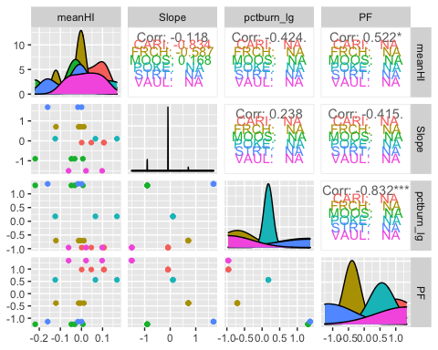

# ggsave("pairs1.pdf",  
# width = 10, height = 10)

# HI model

turb_data_year$logmeanHI <- log(abs(turb_data_year$meanHI))  
  
HI.turb.year.log <- lmer(logmeanHI ~ CatPF*pctburn_lg + (1|year),   
 data = turb_data_year)  
  
summary(HI.turb.year.log) # year is adding some variance

## Linear mixed model fit by REML ['lmerMod']  
## Formula: logmeanHI ~ CatPF * pctburn_lg + (1 | year)  
## Data: turb_data_year  
##   
## REML criterion at convergence: 75.3  
##   
## Scaled residuals:   
## Min 1Q Median 3Q Max   
## -1.6516 -0.4202 0.3190 0.6556 1.3326   
##   
## Random effects:  
## Groups Name Variance Std.Dev.  
## year (Intercept) 0.7518 0.8671   
## Residual 2.4325 1.5596   
## Number of obs: 21, groups: year, 4  
##   
## Fixed effects:  
## Estimate Std. Error t value  
## (Intercept) -3.8480 0.7983 -4.820  
## CatPFmedium 0.4545 0.7750 0.586  
## pctburn_lg -0.6799 0.5484 -1.240  
## CatPFmedium:pctburn_lg 1.0121 0.7034 1.439  
##   
## Correlation of Fixed Effects:  
## (Intr) CtPFmd pctbr_  
## CatPFmedium -0.716   
## pctburn_lg -0.139 0.144   
## CtPFmdm:pc_ 0.112 -0.093 -0.780

# pctburn_lg is more important individually but the interaction term is most significant though it has a low t-value(1.439)  
  
vif(HI.turb.year.log)

## CatPF pctburn_lg CatPF:pctburn_lg   
## 1.021940 2.582479 2.551539

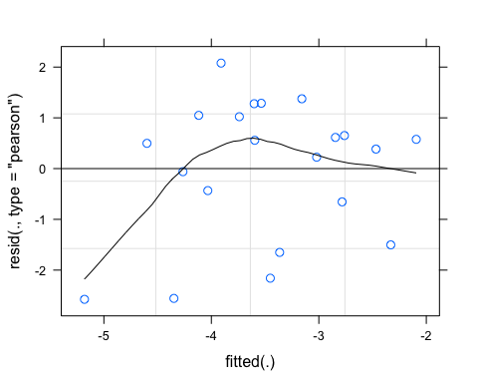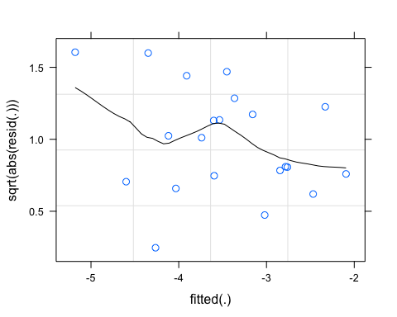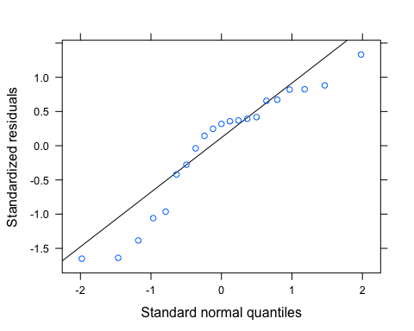

pr <- ggpredict(HI.turb.year.log)  
plot(pr, add.data = TRUE)

## $CatPF

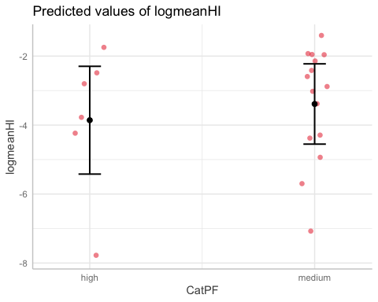

##   
## $pctburn_lg

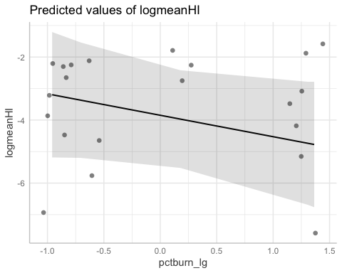

ggplot(turb_data_year, aes(x = pctburn_lg, y = meanHI, color = CatPF)) +  
 geom_point() +  
 geom_smooth(method = "lm", na.rm = TRUE, fullrange = TRUE, aes(group = CatPF)) +  
 stat_poly_eq(formula = y~x,  
 label.y = "top", label.x = "right",  
 aes(label = paste(..eq.label.., ..rr.label.., sep = "~~~")),   
 parse = TRUE) +   
 theme_classic()

## `geom_smooth()` using formula 'y ~ x'

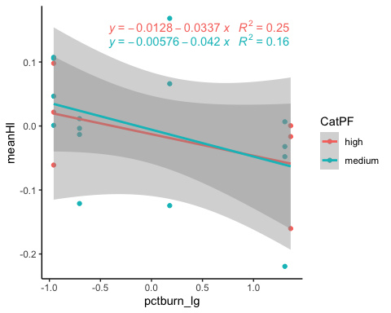

# BETA model

BETA.turb.year <- lmer(meanBETA ~ CatPF*pctburn_lg + (1|year),   
 data = turb_data_year)  
summary(BETA.turb.year) # year is adding variance

## Linear mixed model fit by REML ['lmerMod']  
## Formula: meanBETA ~ CatPF * pctburn_lg + (1 | year)  
## Data: turb_data_year  
##   
## REML criterion at convergence: 17.5  
##   
## Scaled residuals:   
## Min 1Q Median 3Q Max   
## -1.3582 -0.7423 -0.1777 0.5808 2.2940   
##   
## Random effects:  
## Groups Name Variance Std.Dev.  
## year (Intercept) 0.003672 0.0606   
## Residual 0.092565 0.3042   
## Number of obs: 21, groups: year, 4  
##   
## Fixed effects:  
## Estimate Std. Error t value  
## (Intercept) 1.075930 0.130720 8.231  
## CatPFmedium -0.356077 0.149223 -2.386  
## pctburn_lg -0.035455 0.106974 -0.331  
## CatPFmedium:pctburn_lg 0.008451 0.137211 0.062  
##   
## Correlation of Fixed Effects:  
## (Intr) CtPFmd pctbr_  
## CatPFmedium -0.826   
## pctburn_lg -0.166 0.145   
## CtPFmdm:pc_ 0.130 -0.093 -0.780

# PF is the big player here  
  
vif(BETA.turb.year)

## CatPF pctburn_lg CatPF:pctburn_lg   
## 1.022750 2.585563 2.552773

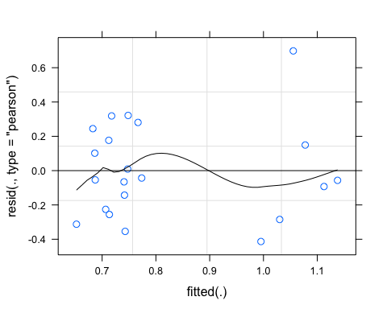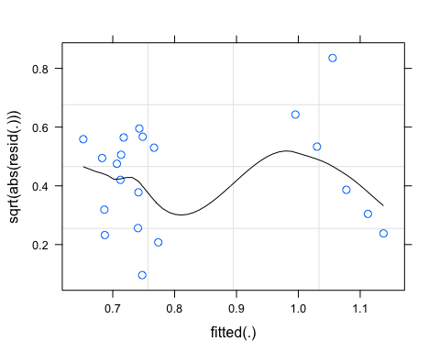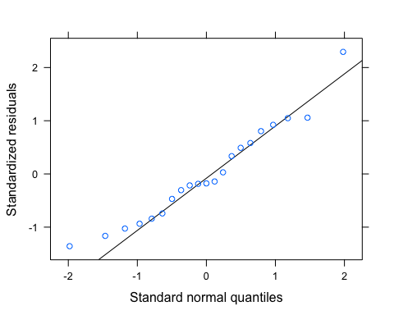

pr <- ggpredict(BETA.turb.year)  
plot(pr, add.data = TRUE)

## $CatPF

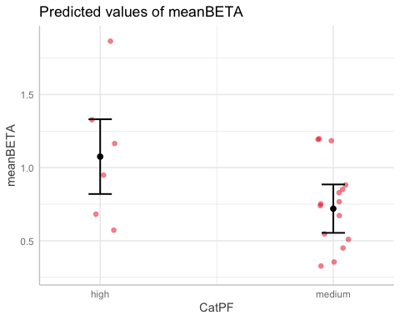

##   
## $pctburn_lg

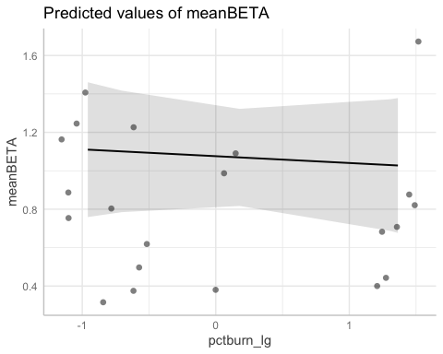

ggplot(turb_data_year, aes(x = pctburn_lg, y = meanBETA, color = CatPF)) +  
 geom_point() +  
 geom_smooth(method = "lm", na.rm = TRUE, fullrange = TRUE, aes(group = CatPF)) +  
 stat_poly_eq(formula = y~x,  
 label.y = "top", label.x = "right",  
 aes(label = paste(..eq.label.., ..rr.label.., sep = "~~~")),   
 parse = TRUE) +   
 theme_classic()

## `geom_smooth()` using formula 'y ~ x'

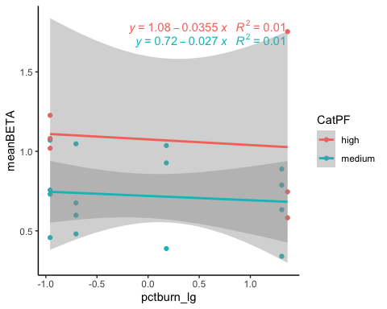

# CVHI model

CVhi.turb.year <- lmer(CVhi ~ CatPF*pctburn_lg + (1|year),   
 data = turb_data_year)  
summary(CVhi.turb.year)

## Linear mixed model fit by REML ['lmerMod']  
## Formula: CVhi ~ CatPF * pctburn_lg + (1 | year)  
## Data: turb_data_year  
##   
## REML criterion at convergence: 193.8  
##   
## Scaled residuals:   
## Min 1Q Median 3Q Max   
## -1.44525 -0.29725 0.01276 0.10972 2.84784   
##   
## Random effects:  
## Groups Name Variance Std.Dev.  
## year (Intercept) 343 18.52   
## Residual 2821 53.11   
## Number of obs: 21, groups: year, 4  
##   
## Fixed effects:  
## Estimate Std. Error t value  
## (Intercept) 35.78 24.31 1.472  
## CatPFmedium -30.82 26.20 -1.177  
## pctburn_lg 32.66 18.67 1.749  
## CatPFmedium:pctburn_lg -35.92 23.95 -1.500  
##   
## Correlation of Fixed Effects:  
## (Intr) CtPFmd pctbr_  
## CatPFmedium -0.787   
## pctburn_lg -0.156 0.145   
## CtPFmdm:pc_ 0.123 -0.093 -0.780

vif(CVhi.turb.year)

## CatPF pctburn_lg CatPF:pctburn_lg   
## 1.022389 2.584200 2.552225

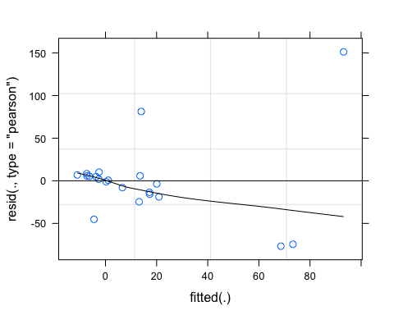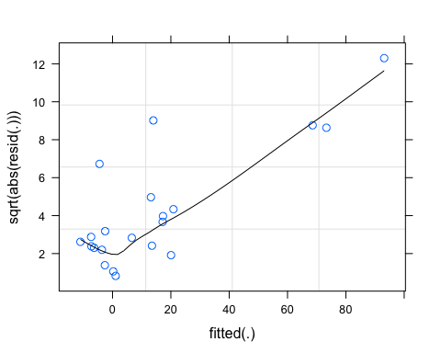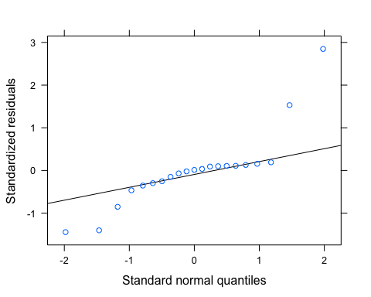 lets log transform

# log transform   
turb_data_year$logCVhi <- log(abs(turb_data_year$CVhi))  
  
CVhi.turb.year.log <- lmer(logCVhi ~ CatPF*pctburn_lg + (1|year),   
 data = turb_data_year)  
summary(CVhi.turb.year.log)

## Linear mixed model fit by REML ['lmerMod']  
## Formula: logCVhi ~ CatPF * pctburn_lg + (1 | year)  
## Data: turb_data_year  
##   
## REML criterion at convergence: 74.9  
##   
## Scaled residuals:   
## Min 1Q Median 3Q Max   
## -1.2122 -0.6840 -0.3085 0.4881 1.5552   
##   
## Random effects:  
## Groups Name Variance Std.Dev.  
## year (Intercept) 0.4999 0.707   
## Residual 2.4775 1.574   
## Number of obs: 21, groups: year, 4  
##   
## Fixed effects:  
## Estimate Std. Error t value  
## (Intercept) 1.7596 0.7588 2.319  
## CatPFmedium -0.3780 0.7794 -0.485  
## pctburn_lg 0.6972 0.5534 1.260  
## CatPFmedium:pctburn_lg -1.0552 0.7099 -1.486  
##   
## Correlation of Fixed Effects:  
## (Intr) CtPFmd pctbr_  
## CatPFmedium -0.754   
## pctburn_lg -0.148 0.144   
## CtPFmdm:pc_ 0.118 -0.093 -0.780

vif(CVhi.turb.year.log)

## CatPF pctburn_lg CatPF:pctburn_lg   
## 1.022154 2.583304 2.551867

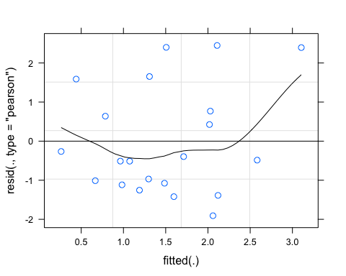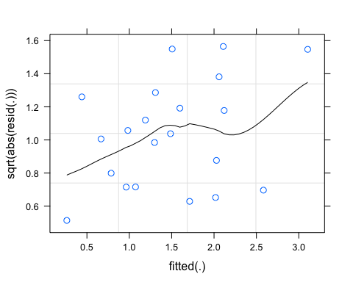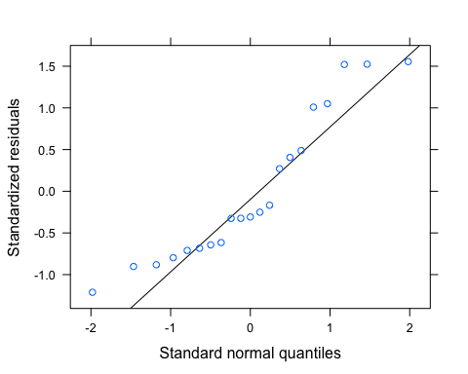

pr <- ggpredict(CVhi.turb.year.log)  
plot(pr, add.data = TRUE)

## $CatPF

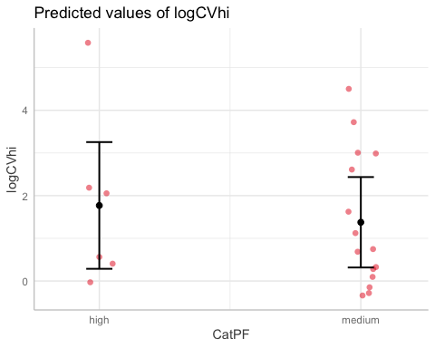

##   
## $pctburn_lg

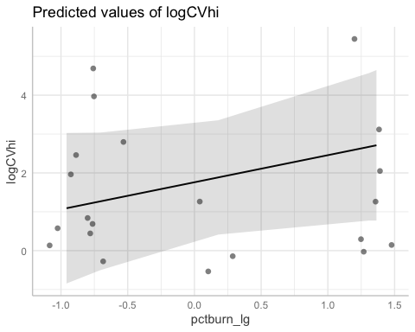

ggplot(turb_data_year, aes(x = pctburn_lg, y = CVhi, color = CatPF)) +  
 geom_point() +  
 geom_smooth(method = "lm", na.rm = TRUE, fullrange = TRUE, aes(group = CatPF)) +  
 stat_poly_eq(formula = y~x,  
 label.y = "top", label.x = "right",  
 aes(label = paste(..eq.label.., ..rr.label.., sep = "~~~")),   
 parse = TRUE) +   
 theme_classic()

## `geom_smooth()` using formula 'y ~ x'

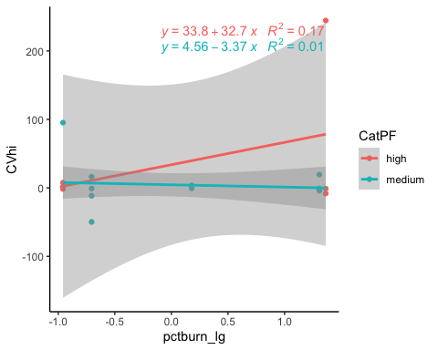

# CVBETA model

turb_data_year$logCVbeta <- log(abs(turb_data_year$CVbeta))  
  
CVbeta.turb.year.log <- lmer(logCVbeta ~ CatPF*pctburn_lg + (1|year),   
 data = turb_data_year)

## boundary (singular) fit: see ?isSingular

summary(CVbeta.turb.year.log)

## Linear mixed model fit by REML ['lmerMod']  
## Formula: logCVbeta ~ CatPF * pctburn_lg + (1 | year)  
## Data: turb_data_year  
##   
## REML criterion at convergence: 50.6  
##   
## Scaled residuals:   
## Min 1Q Median 3Q Max   
## -2.68697 -0.37995 -0.00862 0.41981 1.72124   
##   
## Random effects:  
## Groups Name Variance Std.Dev.  
## year (Intercept) 0.0000 0.0000   
## Residual 0.6702 0.8187   
## Number of obs: 21, groups: year, 4  
##   
## Fixed effects:  
## Estimate Std. Error t value  
## (Intercept) -0.08196 0.33928 -0.242  
## CatPFmedium -0.10413 0.39997 -0.260  
## pctburn_lg 0.39855 0.28784 1.385  
## CatPFmedium:pctburn_lg -0.57804 0.36920 -1.566  
##   
## Correlation of Fixed Effects:  
## (Intr) CtPFmd pctbr_  
## CatPFmedium -0.848   
## pctburn_lg -0.172 0.146   
## CtPFmdm:pc_ 0.134 -0.092 -0.780  
## optimizer (nloptwrap) convergence code: 0 (OK)  
## boundary (singular) fit: see ?isSingular

vif(CVbeta.turb.year.log)

## CatPF pctburn_lg CatPF:pctburn_lg   
## 1.023000 2.586499 2.553152

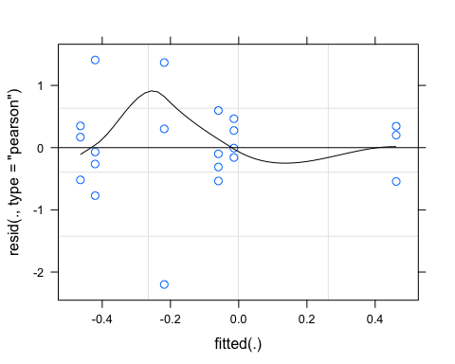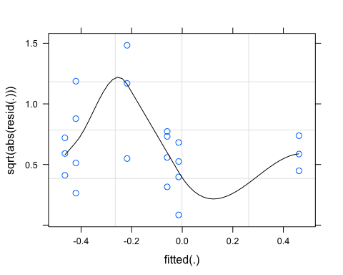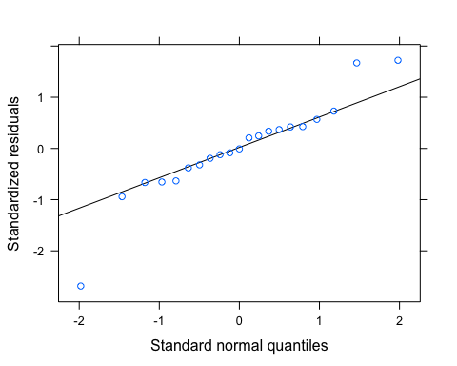

pr <- ggpredict(CVbeta.turb.year.log)  
plot(pr, add.data = TRUE)

## $CatPF

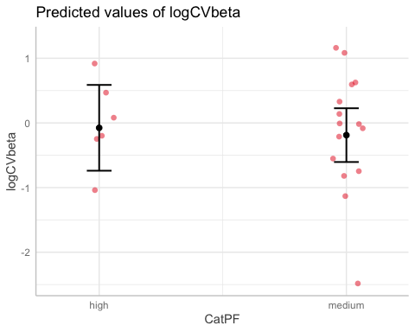

##   
## $pctburn_lg

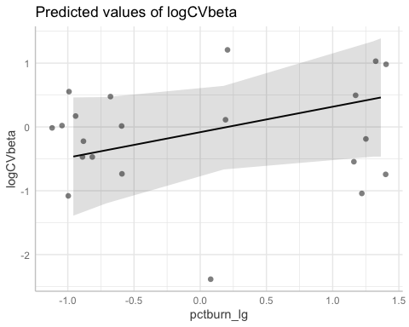

ggplot(fDOM_data_year, aes(x = pctburn_lg, y = CVbeta, color = CatPF)) +  
 geom_point() +  
 geom_smooth(method = "lm", na.rm = TRUE, fullrange = TRUE, aes(group = CatPF)) +  
 stat_poly_eq(formula = y~x,  
 label.y = "top", label.x = "right",  
 aes(label = paste(..eq.label.., ..rr.label.., sep = "~~~")),   
 parse = TRUE) +   
 theme_classic()

## `geom_smooth()` using formula 'y ~ x'



CVbeta.turb <- lm(logCVbeta ~ CatPF*pctburn_lg,   
 data = turb_data_year)  
summary(CVbeta.turb) # nothing is significant

##   
## Call:  
## lm(formula = logCVbeta ~ CatPF * pctburn_lg, data = turb_data_year)  
##   
## Residuals:  
## Min 1Q Median 3Q Max   
## -2.19971 -0.31105 -0.00706 0.34368 1.40911   
##   
## Coefficients:  
## Estimate Std. Error t value Pr(>|t|)  
## (Intercept) -0.08196 0.33928 -0.242 0.812  
## CatPFmedium -0.10413 0.39997 -0.260 0.798  
## pctburn_lg 0.39855 0.28784 1.385 0.184  
## CatPFmedium:pctburn_lg -0.57804 0.36920 -1.566 0.136  
##   
## Residual standard error: 0.8187 on 17 degrees of freedom  
## Multiple R-squared: 0.1377, Adjusted R-squared: -0.0145   
## F-statistic: 0.9047 on 3 and 17 DF, p-value: 0.4593

plot(CVbeta.turb)

